2022 WSU Impact Report
Table of Contents
Graphic overview 2
University history 6
Economic contribution 8
University spending 8
Impact by WSU and WSU Tech 10
Impact by source 12
Industry impact 14
Research impact 16
Tourism impact 23
Student impact 25
Community engagement and comparison 27
Headcount 27
Student age 31
Industry and occupation 34
Diversity 35
Cost and affordability 39
Financial aid and need 42
Appendix 44
Faculty and staff headcounts 44
Economic contribution - Wichita State University 46
WSU Tech 46
Research 46
Board of Trustees 46
Foundation 46
Athletics 46
Union (RSC) 47
Community engagement and comparison 48
Research impact 56

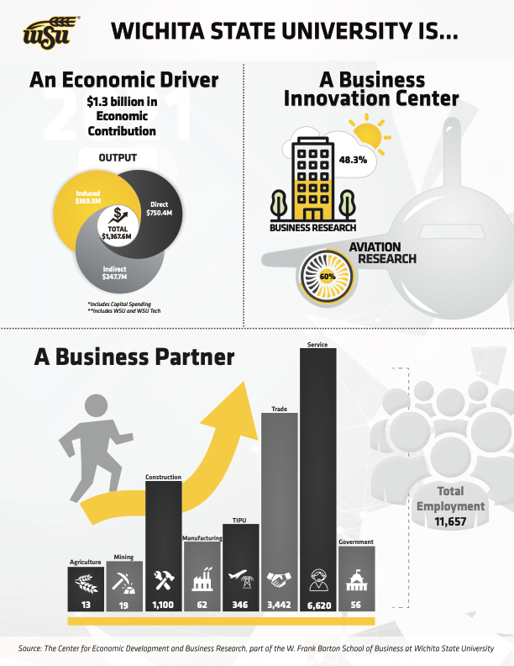

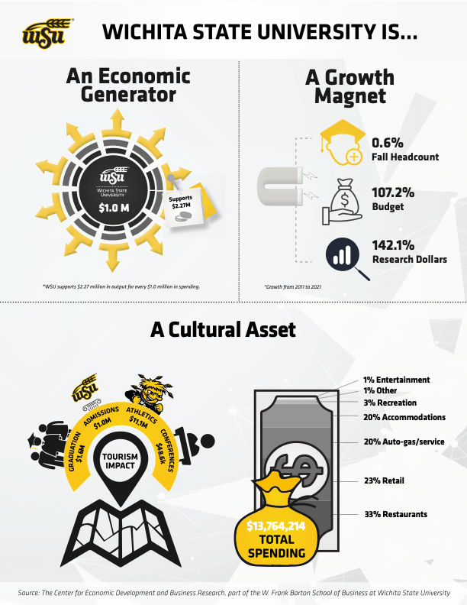

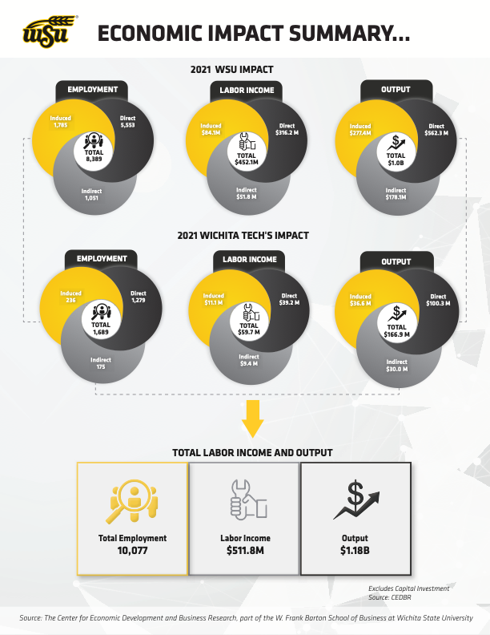

University History
Wichita State University is Kansas' only urban public research university, enrolling almost 22,000 students between its main campus and WSU Tech, including students from every state in the United States and more than 100 countries. Wichita State and WSU Tech are recognized for being student-centered and innovation driven.

Located in the largest city in the state with one of the highest concentrations in the United States of jobs involving science, technology, engineering and math (STEM), Wichita State University provides uniquely distinctive and innovative pathways of applied learning, applied research and career opportunities for all of our students.

Wichita State was established in 1895 when it was named Fairmount College. In 1925, it became the Municipal University of Wichita, and became Wichita State University in 1964 when it became a member of the state university system. It is accredited by the Higher Learning Commission of North Central Association of Colleges and Schools.

The City of Wichita is centrally located within the nation along the I-35 corridor between Kansas City and Oklahoma City. The area has a total population of 647,610 and a Gross Regional Product of more than $36.3 billion, as reported in 2020. The region's industrial clusters are aerospace manufacturing and energy.

The university is organized into nine colleges and offers more than 460 undergraduate, graduate, and professional degrees and certificates. In 2017, the university began its official affiliation with WSU Tech, which offers more than 100 degrees in aviation, healthcare, manufacturing, general education and business, and design.

WSU is home to dozens of centers and institutes that conduct commercial research for business, industry, the government as well as academia. One of the most notable institutes is the National Institute for Aviation Research (NIAR), which was established in 1985 to provide research, design, testing, certification, and training for the local manufacturing industry. With almost $200 million in yearly R&D expenditures, NIAR employs nearly 1,000 people who work across its six locations in the Wichita metro area.

In 2014 the university transformed a 120-acre golf course on the northeast edge of campus into the Innovation Campus, which is one of the nation’s largest and fastest-growing research and innovation parks with more than 50 businesses and government establishments, including Deloitte’s Smart Factory @ Wichita, NetApp, Spirit AeroSystems, Textron, and the Bureau of Alcohol, Tobacco, Firearms and Explosives. Wichita State’s Innovation Campus has deepened the role of the university in supporting business development, provided thousands of students with applied learning opportunities, and houses dozens of labs and research facilities.

As the premier higher education institution in south central Kansas, it is clear that WSU is a core contributor to the regional economy. It is fulfilling its mission to be an essential educational, cultural and economic driver for Kansas and the greater public good.

The purpose of this study is to determine the specific economic impacts of WSU on regional and state economies, and to quantify the long-term benefits to the community provided by the university. There are two approaches to measuring the economic impact of a project: measuring net new or all economic activity. Measuring net new economic activity works best when adding a new academic program or facility, as both would be new to the regional economy and have zero competition. Measuring all economic activity works best when trying to understand the size and interaction of the project on a regional economy. Since the purpose of this study is to understand how the university impacts the regional economy, all economic activity was included.

Methodology :
This study uses the term economic impact to include all economic activity associated with the university interaction in the regional and state economies. This type of measurement is often referred to as an economic contribution. Economic contributions impacts do not include substitution effects.
- The impact model used to estimate the economic impacts of WSU on the regional and state economies was IMPLAN (Impact analysis for PLANning). IMPLAN is one of the most commonly used models for university impacts. Alternative models are less common in practice and tend to involve a higher level of customization. The advantage of using this model is that it is broadly available and uses straightforward methodologies. Others could replicate the study or even develop similar studies to provide reliability or comparability.
- This study used best practices as laid out by the Association of Public and Land-Grant Universities and Association of American Universities "Economic Engagement Framework: Economic Impact Guidelines" (2014). The study also used the established methodologies developed by IMPLAN, the econometric impact model used to derive the impact estimates.
- The determination of what should be included within the economic contribution study included a "but for" approach. In the "but for" approach, all economic activities that would not have occurred "but for" the existence of Wichita State University were included, provided information was available to capture that market activity. In this way, the study does not include spending that would have been present within the community without the university.
- Double counting is a common weakness of contribution studies. It tends to occur by inputting two similar direct economic activities like salaries and employment, or by adding in an indirect effect on top of a direct effect. This study went to great lengths to prevent double counting by using the Analysis-By-Part technique developed by IMPLAN.
- In the development of the model and in the preparation of analysis, CEDBR assumed all information and data provided was and is accurate and reliable. CEDBR does not take extraordinary steps to verify or audit such information but relies on such information and data as provided for purposes of the project.
- The budget office has removed encumbrances and transfers. Encumbrances were removed because they were not expended during the calendar year, an important element when determining economic activity. Transfers between departments and divisions were removed to prevent double counting.
- Labor Income, or employee compensation, includes wages and salaries and supplements to wages and salaries (employer contributions for retirement, insurance funds, and employer contributions for government social insurance). The only employee compensation not included was tuition benefits. Tuition benefits are a transfer of payment within the university and would lead to double counting. Although it was excluded, this benefit does create long-term value for the regional economy by improving human capital and increasing productivity.
- Measuring the economic contribution using an input-output model only captures the current market transactions. This type of model is referred to as static in that it does not encapsulate the identifiable economic benefits that are accrued over time. Agglomeration effects, which measure the accumulation of benefits over longer periods of time, are better estimated in dynamic equilibrium models. An agglomeration effect includes clustering economic activity around or within a regional economy. These effects work through labor markets (skilled workers), knowledge spillovers (technology and innovations), and competitive industrial clustering. Entrepreneurs and industries have long identified these benefits and tend to locate near research universities like WSU to build off of those synergies.

Economic Contribution

University Spending
Higher education institutions are more complex than the average household might imagine. For Wichita State University, there are several dimensions to consider when developing an economic impact study. For example, the university's core function includes salaries, other operating expenses, and construction. However, there are multiple other factors of the university that impact the regional economy, like tourism spending, donations to the foundation, and student spending, that are not included within the budget. Furthermore, some organizations, like athletics and the foundation, have separate budgets that were not included in the university's annual expenditure statements.

With the assistance of the university's budget office, the study has included eight divisions that are more inclusive than what is reported annually for Wichita State University. The two, when added together, that most closely align with the annual report are research and WSU. Research includes federal and state grants along with business contracts, all services that cross multiple colleges, schools, and centers within Wichita State University. This study agglomerated those expenditures into one category to highlight the value research has on the state economy. In fiscal year 2021, research expenditures accounted for $177.3 million, or 34.7% of the overall expenditures. By removing research from the budget, the WSU line includes all the remaining core activities of the university, which includes faculty and administrative staff.

Wichita State Innovation Alliance was added to the overall impact, as this nonprofit organization was recently created as a governing entity over the Innovation Campus. Although there was no cash outflow in 2021, the organization has played a role in the regional economy. The Innovation Campus includes GoCreate, a Koch collaborative, research labs, student housing, several businesses, and other activities. All of these functions are core to the university's growth strategy of engaging businesses and providing applied research experiences. Although this study included the Wichita State Innovation Alliance, private companies like Airbus, Starbucks, and Fuzzy's Taco Shop were excluded.

The Board of Trustees, which was created the same year that the university was added to the Kansas Board of Regents, was included in the university impact, as its sole purpose is to support the university, though it has a separate budget. Its mission includes managing the university's endowment and the one and one-half mill levy funding that was initially established when it became a municipal college. Although the WSU Foundation and Alumni Engagement is a separate nonprofit organization, its sole purpose is to support the university by aligning donors with opportunities on campus like scholarships, research grants, and facilities. Using the "but for" test, this entity would not exist within the community without the university. Therefore, all expenditures need to be included within the economic impact. The $23.5 million spent in fiscal year 2021 represents only direct cash outflow of the organization and excludes transfers to a department within Wichita State University.
The total expenditures from the Athletics department, which is also a separate entity from the university, was $23.9 million in fiscal year 2021. The $23.9 million in cash outflows represent a total 4.0% of the broader university's direct impact within Sedgwick County. WSU Tech, which was founded in 1965 and merged with Wichita State University in 2018, provides technical educational opportunities on four campuses within the Wichita Metropolitan Area. Total expenditures in fiscal year 2021 were $34.6 million. The merger with WSU provides synergy and an increase in quality education, an educational pipeline between the two, and it aligns both to focus on the regional workforce needs. It is important to note that there is one substantial difference between the 2020 University Impact study and this one is that WSU Tech was intentionally left out in the previous report.

The WSU Union, also known as Rhatigan Student Center, is another organization with a separate budget but is an integral piece of the delivery of services of the university to both students and faculty. The $9.9 million expenditures support several activities, including food services.

Did You Know?
WSU provides quality education and resources to students and community members through its multiple campuses across the metro area, including: Main, West, South, Metropolitan Complex, Haysville, Old Town, Shocker Studios—and WSU Online.

The budget is divided into three categories: labor income, other operating, and capital investments. In the 2021 fiscal year, the total employee compensation across all types was $214.4 million, or 42% of the total cash outflow. Labor income includes faculty, staff, and graduate research positions. Other operating expenditures include the daily non-payroll expenses for running the university, such as paper, travel expenses, postal, and bank charges. Capital expenditures are accounted separately from the university operations, as these types of activities are typically one-time expenditure items that have use over a number of years. The capital improvement projects reported by the university include spending on building, equipment, and land improvements, as well as major renovations to buildings. The 2021 capital expenditures accounted for 16.2% of the total, or $82.8 million.
FY 2021 Expenditures (Cash Outflows)
 |  | Labor | OOE |  | Capital | Total
WSU, less Research |  | $162,988,521 | $108,899,958 |  | $61,820,982 | $333,709,460
WSU Research |  | $51,425,059 | $104,964,349 |  | $20,938,030 | $177,327,439
Total WSU |  | $214,413,580 | $213,864,307 |  | $82,759,012 | $511,036,899
Board of Trustees |  | $0 | $3,201,774 |  | $0 | $3,201,774
Foundation |  | $4,460,422 | $15,855,345 |  | $0 | $20,315,767
Athletics |  | $13,741,500 | $10,124,299 |  | $0 | $23,865,799
WSU Tech |  | $17,824,595 | $11,677,285 |  | $5,088,472 | $34,590,352
WSU Union (RSC) |  | $2,677,472 | $7,047,107 |  | $133,521 | $9,858,100
Total Component Units |  | $38,703,989 | $47,905,810 |  | $5,221,993 | $91,831,792
Grand Total 2021 |  | $253,117,569 | $261,770,117 |  | $87,981,005 | $602,868,691
Source: CEDBR

Wichita State University alone had $214.4 million in payroll spending, which supports 2,533 faculty and staff positions in the fall of 2021. Of those employees, 118 live outside of Kansas across 30 states. The majority living outside of Kansas reside in Missouri, Oklahoma, and Texas. Although some of the income will leak out of the Kansas economy, as they likely will spend money on housing and food within their state of residency, the dispersion shows the broad labor pool drawn for providing expertise for instruction and services to the Wichita community. Attracting specialized labor across the nation increases the overall quality of the services offered by WSU to the regional market. The majority of employees live within Kansas, 81.3% of total faculty and staff residing in Sedgwick County alone. This high concentration means that the spillover effect of the earnings of WSU workers on consumption items like groceries, doctor visits, and purchases of vehicles will likely be captured within the immediate area. Butler, Harvey, Sumner, Cowley, and Marion were the top five counties with WSU employees outside Sedgwick County, with 175, 45, 24, 11, and 9, respectively. The concentration of employees within the immediate region reflects the high inter-dependency within the regional market.
WSU Tech had $17.8 million in payroll expenditures and 550 faculty and staff positions in the fall of 2020. At the time of this report, information about where they lived was unknown; however, it is more likely that the majority of employees live within the immediate area than Wichita State University. Thus, the impact from those households is likely even more concentrated within Kansas and surrounding counties.

Impact by WSU and WSU Tech

Did You Know?
WSU was one of the first educational institutions in the nation to offer a degree in aerospace engineering— way back in 1928.

Did You Know?
Wichita Police officers and Sedgwick County sheriff’s deputies train on campus in the new Law Enforcement Training Center, which is also home to WSU’s School of Criminal Justice, one of the first such academic programs in the nation.

Wichita State University and WSU Tech merged in 2017. Joining the two organizations provided strategic financial advantages for both entities and established a more holistic career pathway for entering and advancing in the regional labor market. The state and regional economies are more concentrated in the production sectors of the economy, requiring both more and higher-skilled blue-collar workers. A significant gap in manufacturing economies worldwide is the training of blue-collar workers as they progress into management and service roles. Providing a clear pathway for someone to enter the workforce in an occupation like welding to management and even data analytics provides value to both the individual and employer. The worker benefits from increased wages and quality of life, and the employer benefits from a dynamic labor market with higher productivity levels.

This section highlights the economic contributions of WSU and WSU Tech separately and together. It is important to note that although the budgets are currently separate, the impacts are likely interconnected as they share resources.
The 3,083 joint faculty and staff at both WSU and WSU Tech, along with their other operating expenses, support 5,293 jobs and $342 million in annual labor income within the Kansas economy. Both academic units purchase goods and services within the region and state. Those purchases include printing, food, and professional services, which spill over to firms. The direct spending on other operating expenditures in 2021 was $262 million, which created a total economic impact of $557.2 million.

The direct spending captured within the university budget does not capture all of the economic benefits. This study also includes student spending and tourism activity. Using the "but for " method, the students attending the university would not stay within the 10-county area but for WSU, as there is no comparable state research university locally. Therefore, this study includes all students spending during their tenure. Student spending was estimated to have a total impact of 4,555 jobs, $162 million in labor income, and over $603.7 million in output activity by purchasing retail goods, food, entertainment, and housing.

Tourism spending is also important to capture, as the visitors would not have spent the night, purchased Shocker memorabilia, or eaten at local restaurants if it had not been for the presence of the university. This study only included tourism activities from athletics, WSU Conference Management Services, WSU graduation, and WSU admission, which grossly underestimates the full scope of tourism activity. The economic contribution from the four tourism components captured within this study account for 230 jobs, $7.7 million in labor income, and $23.8 million in output. It is important to note that the economic contributions were lower than in the previous estimate due to the lingering ramifications of COVID-19.
Capital investments were included separately in the total contribution impact, as the funding tends to be one-time expenditures and varies dramatically by year. Capital investments include expenditures on lab equipment, software, vehicles, furniture, lawn equipment, new buildings, and renovations.

Construction-related projects support temporary jobs, as the projects have a limited duration. The purchase of major equipment tends to leak out of the region. For this reason, the accepted practice is to separate out capital investments from the total contribution impact. WSU, however, is consistently spending on capital investments. Excluding these expenditures entirely would overly discount the value it provides. All capital investments accounted for $90.5 million in fiscal year 2021. Those investments generated 1,580 jobs, $90.5 million in labor income, and a total output of $183 million in economic activity.

The total expenditures from WSU and WSU Tech were $602.9 million in 2021. Comparing that economic activity to the total economic output creates a multiplier effect. Dividing the $1.38 billion in the total impact by direct spending creates a multiplier of 2.27. For every million dollars spent, both academic units support an additional $1.27 million of activity among Kansas businesses.

2021 Total Economic Contribution
Employment
 | WSU | WSU Tech | Total
Expenditure | 4,632 | 661 | 5,293
Student | 3,527 | 1,028 | 4,555
Tourism | 230 | - | 230
Capital | 1,489 | 92 | 1,580
Total | 9,877 | 1,780 | 11,657
Labor Income
 | WSU | WSU Tech | Total
Expenditure | $318,832,760 | $23,120,845 | $341,953,605
Student | $125,657,685 | $36,566,582 | $162,224,267
Tourism | $7,657,809 |  | $7,657,809
Capital | $85,233,681 | $5,240,628 | $90,474,309
Total | $537,381,935 | $64,928,055 | $602,309,990
Output
 | WSU | WSU Tech | Total
Expenditure | $527,689,622 | $29,490,058 | $557,179,680
Student | $466,246,168 | $137,422,986 | $603,669,154
Tourism | $23,780,045 | $ - | $23,780,045
Capital | $172,416,582 | $10,601,105 | $183,017,687
Total | $1,190,132,417 | $177,514,149 | $1,367,646,566
Source: CEDBR

Impact by Source
Did You Know?
During the coronavirus pandemic, the WSU Molecular Diagnostics Lab engaged with the community, employing over 100 and partnering with over 600 community organizations. This led to over 400,000 PCR tests and the development of an RSV, Influenza, and COVID-19 detection test that kept over 60,000 community members informed and able to get back to work.

Did You Know?
In its first year of operation, the WISE Play Therapy and Counseling Clinic provided free mental health services to more than 230 members of the community via more than 1,400 sessions. The College of Applied Studies has applied learning agreements with more than 400 partners, including school districts, counseling service providers and sport/fitness organizations.

For each dollar spent by both academic units, an interaction is generated within the marketplace. As the university consumes local retail goods, for example, those businesses hire employees and purchase inventory to restock shelves. The first dollar generated is called the direct effect. The creation of a job within a retail store and its output is called the indirect effect. In fiscal year 2021, WSU and WSU Tech directly generated a total output of $662.6 million of economic activity. The supply chain for the academic entities generated an additional $208 million dollars of economic activity.

The multiplier effect does not stop there, as there is still spending from the employees. Examples of this include when faculty and staff spend their paychecks to pay rent, utilities, buy groceries, visit the doctor, and consume entertainment, like attending Exploration Place. The $253 million in direct labor income flows into the economy, generating additional jobs at businesses like Evergy, Ascension Via Christi, and Music Theater Wichita. This impact is called the induced effect, which adds $323.9 million in consumption. Combining the direct, indirect, and induced effects creates the total impact and multiplier. Therefore, the 3,437 jobs directly created by academic entities further support 1,226 indirect jobs and 2,020 induced jobs. The job multiplier was 3.39. For every job created by the university, there are an additional 2.39 jobs supported in Kansas.

Wayne and Kay Woolsey Hall, the state-of-the-art facility that is home to the W. Frank Barton School of Business at Wichita State University, opened for classes in August 2022.
Woolsey Hall is focused on creating an environment for students and faculty that inspires collaboration, innovation and an entrepreneurial mindset. Its location on the Innovation Campus nurtures applied learning experiences with partners and businesses active there. It is anticipated that the 125,000-square-foot building will be certified with a Leadership in Energy and Environmental Design (LEED) Silver rating, the most widely used green building rating system.

Key features of Woolsey Hall include a social staircase, a curated art collection including both outdoor sculptures and interior pieces, ample study rooms and collaborative spaces, state-of-the-art classrooms with flexible learning environments, the Cargill Café, Fidelity Bank Ballroom and the Frank A. Boettger Auditorium, which seats 300 people. All of these amenities are available to the Wichita State community.

At the October 2020 groundbreaking ceremony for the building, Barton School Dean Larisa Genin told students the facility will be a place “where you will explore your full potential and ambitions.

2021 Employment - Economic Contribution
 | Direct Effect | Indirect Effect | Induced Effect | Total Effect | Total Capital
*WSU (excluding research) | 4,511 | 724 | 1,337 | 6,573 | 1,111.90
Research | 652 | 179 | 293 | 1,123 | 376.60
Board of Trustees | - | 5 | 1 | 7
Foundation | 54 | 39 | 32 | 125
**Athletics | 303 | 92 | 100 | 495
***WSU Tech | 1,279 | 175 | 236 | 1,689 | 92
WSU Union | 33 | 12 | 21 | 66 | 2
Total | 6,831 | 1,226 | 2,020 | 10,077 | 1,582
*Includes tourism and student spending
**Includes tourism spending
***Includes student spending
Source: CEDBR

2021 Labor Income - Economic Contribution
 | Direct Effect | Indirect Effect | Induced Effect | Total Effect |  | Total Capital
*WSU (excluding research) | $237,875,603.00 | $37,848,781.00 | $63,036,383.00 | $338,760,764.00 |  | $63,669,560
Research | $52,548,336 | $7,813,793 | $13,800,027 | $74,162,156 |  | $21,564,121
Board of Trustees | $34,264 | $238,348 | $62,373 | $334,985
Foundation | $4,665,924 | $2,003,315 | $1,524,830 | $8,194,069
**Athletics | $17,437,533 | $3,266,485 | $4,733,153 | $25,437,172
***WSU Tech | $39,165,167 | $9,415,099 | $11,107,161 | $59,687,427 |  | $5,240,628
WSU Union | $3,607,810 | $672,317 | $978,982 | $5,259,109 | $137,514
Total | $355,334,637.00 | $61,258,138.00 | $95,242,909.00 | $511,835,682.00 | $90,611,823.00
*Includes tourism and student spending
**Includes tourism spending
***Includes student spending
Source: CEDBR

2021 Output - Economic Contribution
 |  | Direct Effect | Indirect Effect | Induced Effect | Total Effect | Total Capital
*WSU (excluding research) |  | $410,070,739.00 | $125,484,022.00 | $207,813,145.00 | $743,367,906.00 | $128,795,187
Research |  | $104,964,351 | $32,617,262 | $45,494,899 | $183,076,512 | $43,621,395
Board of Trustees |  | $3,201,774 | $994,939 | $205,421 | $4,402,134
Foundation |  | $15,855,345 | $5,467,789 | $5,026,504 | $26,349,638
**Athletics |  | $21,146,390 | $11,025,447 | $15,604,806 | $47,776,644
***WSU Tech |  | $100,299,021 | $29,999,790 | $36,614,233 | $166,913,044 | $10,601,105
WSU Union |  | $7,047,107 | $2,470,399 | $3,225,494 | $12,743,001 | $278,172
Total |  | $662,584,727.00 | $208,059,648.00 | $313,984,502.00 | $1,184,628,879.00 | 183,295,859.00
*Includes tourism and student spending
**Includes tourism spending
***Includes student spending
Source: CEDBR

Industry Impact
A university creates jobs through its mission of higher education, research, scholarship, training, and other outreach activities; but it can also provide jobs to local businesses that supply goods and services to university employees and students. Those interactions are part of the university's supply chain. After discounting the employees from WSU within the service sector, the largest industry that the university impacts is the retail sector. The retail sector not only supplies some of the office materials but is also connected with employees' household spending and students’ consumption. University towns are often noted for having lively retail spaces with unique goods, as university employees tend to have higher median incomes and students have higher discretionary budgets. The second largest category is TIPU, or Transportation, Information, and Public Utilities. Within this sector, it is public utilities that have the largest share of activity, as the employees and students all require housing and consume both electricity and water.

Because this study used a static input-output model, it did not capture how faculty, staff, and students affect home price appreciation, an essential component that is part of personal wealth and directly impacts the housing market. At some universities, especially in small towns, housing prices tend to be higher than in comparable non-university towns, as they tend to draw people in to live within the more robust communities.

The economic contribution to the manufacturing sectors was estimated to support 62 jobs and a total of $4 million in labor income. The way that the model captures the inter-industry transactions is through purchases from the university, employees, and students. The calculation only captures the purchases from the university directly to manufacturing, which would likely be for customized machinery to be used within a research lab.

The model does not account for the importance of information transfers, student employment opportunities, or non-financial transactions. The dominance of the aerospace manufacturing cluster within South Central Kansas would not have evolved into the economic driver it is today without the highly intertwined relationship with the university. As the aerospace industry was emerging, the sector needed skilled labor and specialized training for workers and engineers. That demand gave rise to the growth of WSU's engineering and business programs. As the university accumulated specialized aerospace engineers, the applied research production flowed back to the aerospace companies, giving them a competitive edge over other aerospace businesses globally. This interaction had a circular effect, building steam over several decades. The City of Wichita is highly revered, well-known, and visited among aerospace professionals and enthusiasts globally.

The capital investment across the university and its affiliated organizations also have an impact across multiple sectors of the economy. The construction sector receives the most significant benefit from the capital investment, supporting 1,048 full-time equivalent jobs and generating $61.2 million in labor income. The service sector jobs supported by capital investment include architects, banking, and management of construction companies. The retail and wholesale trade sectors benefit from the purchases of materials and furniture.

2021 Total Industry Contribution
 | Employment | Labor Income | Output
Total | 11,657 | $602,309,990 | $1,367,646,566
Agriculture | 13 | $388,968 | $2,222,704
Mining | 19 | $571,422 | $5,455,659
Construction | 1,100 | $64,902,519 | $99,542,280
Manufacturing | 62 | $4,042,233 | $32,821,243
TIPU | 346 | $23,925,021 | $86,718,878
Trade | 3,442 | $108,282,755 | $319,576,573
Service | 6,620 | $395,666,159 | $805,678,350
Government | 56 | $4,530,912 | $15,630,878
*Includes Capital Investment
Source: CEDBR
2021 Capital Investment
 | Employment | Labor Income | Output
Total | 1,580 | $90,474,309 | $183,017,687
Agriculture | 2 | $41,992 | $211,621
Mining | 7 | $265,762 | $1,884,847
Construction | 1,048 | $61,907,947 | $88,611,454
Manufacturing | 28 | $1,850,002 | $12,586,720
TIPU | 34 | $2,743,153 | $9,385,050
Trade | 116 | $5,171,315 | $17,098,959
Service | 342 | $18,143,246 | $52,217,306
Government | 4 | $350,892 | $1,021,729
Source: CEDBR

Research Impact
Did You Know?
In addition to robust research conducted within its academic departments, WSU is also home to more than 30 research centers and institutes, many of which work closely with local, regional and national entities to accelerate discovery and innovation and bring new products to the marketplace.

Did You Know?
In the Air Force Rapid Sustainment Office Advanced Manufacturing Olympics, NIAR won first place in the Reverse Engineering challenge and third in the F-16 Approval Sprints Additive Manufacturing challenge.

Did You Know?
From 2021 to 2022, NIAR has received numerous awards and grants. Some awards include $100 million to continue B-1 Digital Engineering program, $7.7 million from the FAA for research of Unmanned Aerial Systems, additive manufacturing, and advanced materials, $2.1 million from the US Department of Commerce for the Flight Test and MRO facilities, and $5 million for the WSU-led Defense Manufacturing Community Consortia.

Did You Know?
In FY19, the university exceeded $100 million in annual R&D support for the first time. On-campus research and applied learning partners include Airbus, with 280 resident engineers; Dassault Systemes, with its worldclass 30 Experience Lab employing students and full-time researchers; and Spirit AeroSystems, the state's largest employer. All have come to WSU because of its applied learning and research commitment.

According to the National Higher Education Research and Development Survey, Wichita State University spent $153.8 million on research in 2020. This represented a growth of 19.4% in total research spending for the university since 2019 and a 198.5% increase since 2010. WSU outpaced both its Peer Group and its Aspirant Group in research growth, as the Peer Group's spending increased 68.4% since 2010, and the Aspirant Group's spending grew only 50.9%. Although WSU's research spending grew rapidly in recent years, its research spending was only 65% of the level of its Aspirant Group average and 13.2% of its Peer Group average. The small fraction relative to the Aspirant Group is mainly due to very high research funding at the University of Cincinnati, which alone spent 3.45 times as much as WSU.

The largest share of WSU's research funding is provided by private businesses, which funded more than $81.3 million in WSU research in 2020. This comprised 52.9% of all research spending at WSU, a much higher share than the norm for WSU's Peer and Aspirant Groups, which received 7.0 and 10.0% of their funding from private businesses. Private business was also the fastest growing category of WSU's research funding over the long term, the 2020 value being 259.7% higher than in 2010 but slightly lower than its 2019 peak. Both the 2019 and 2020 private business funding were considerably higher than in 2018, with the 2020 value representing an 86.0% increase.

While WSU is a leader in business-funded research, the university lags behind both its Peers and Aspirants in federal government-funded, state and local government-funded, and institutionally-funded research. Federally funded research comprised only 34.8% of WSU's research spending, totaling $53.5 million. In comparison, its Peers received 42.6%, and Aspirants received 47.6% of funding from the federal government. State and local government-funded research had a similar gap. WSU received 4.3% of its research funding from state and local government sources, compared to 8.9 and 5.0% in the Peer and Aspirant Groups. Finally, institutional funds had a much wider gap in 2020, comprising 6.5% of WSU's research funds compared to 37.2 and 33.4% among Peer and Aspirant groups.

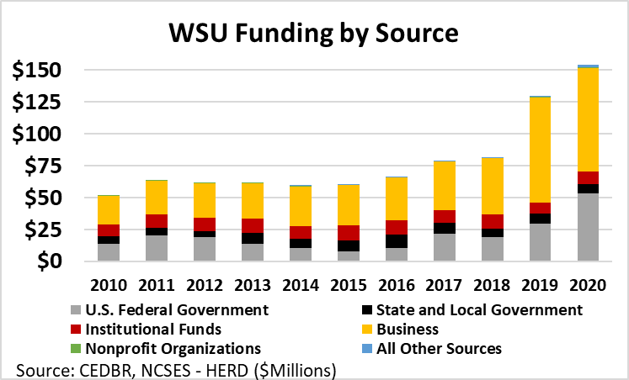

Aerospace research was the largest funded category for WSU over the entire period. More than 85.3% of WSU's total research funding was in the aerospace engineering field, totaling more than $131.2 million in 2020. Funding for aerospace research has grown 263.4% since 2010, significantly faster than national growth in the field at 107.2%. WSU remains a national leader in aerospace engineering, as it has the fourth largest share of all research within this category in 2020, only behind Utah State University, Georgia Institute of Technology, and Johns Hopkins University. WSU alone represented 10.1% of all aerospace research funding nationally in 2020.
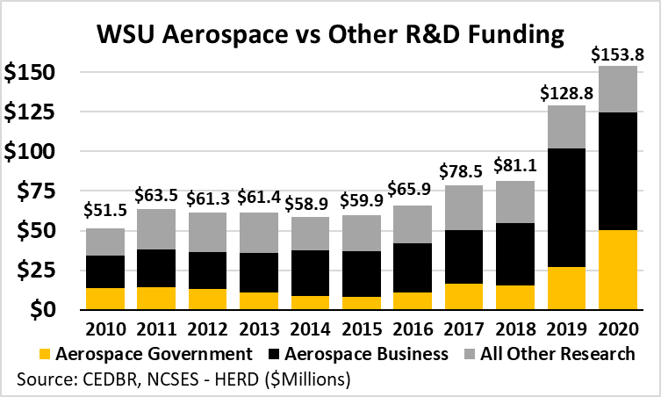

WSU's aerospace research was unique among major aerospace research institutions in that it was primarily funded by private businesses. More than $81 million in WSU aerospace funding was provided by private companies in 2020, representing 59.7% of all research. Because of the heavy influence of aerospace firms, private funding at represents 48.3% of overall total research. This share has declined recently as government funding for aerospace research nearly doubled from 2019 to 2020. Nationally, only $129.5 million of university aerospace research was funded by private businesses, with WSU comprising more than 57.4% of that amount. In addition, WSU's Peer and Aspirant Groups collectively received less than $1 million in aerospace research funding from private firms in 2020.
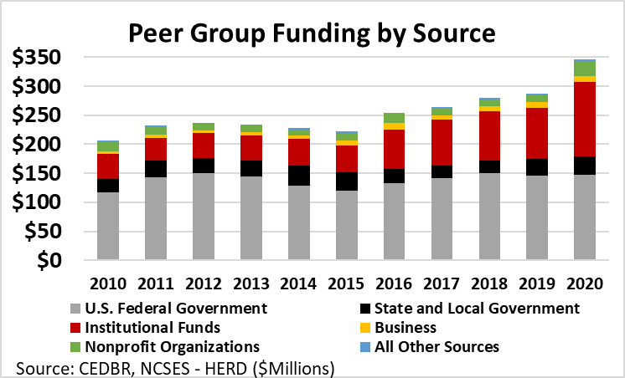
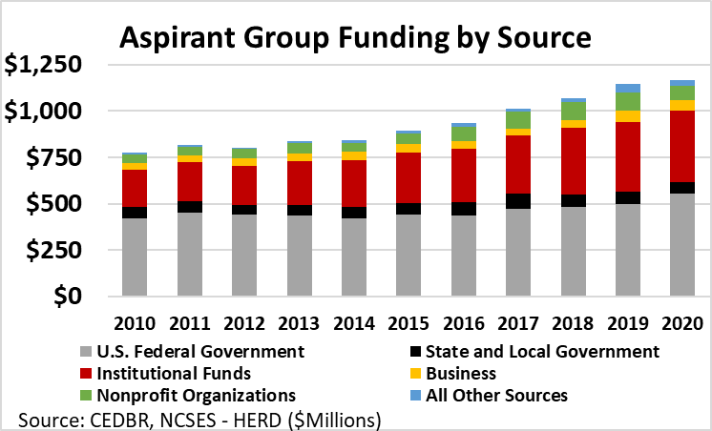

Methodology
- All data in the section was collected by the Higher Education Research and Development Survey (HERD), an annual census conducted by the National Science Foundation of all colleges and universities, which expended more than $150,000 on separately accounted for research and development funding each year.
- Institutional funding includes all funding for research reported as institutionally-financed, such as "competitively awarded internal grants for research, startup packages, bridge funding, seed funding, tuition assistance for student research personnel," in the HERD survey data.
- The economic impact of research has been estimated within the model. The model estimated that the direct labor income of $52.5 million and $104.9 million in other operating activity would likely support 652 jobs across the university. Those 652 jobs support 471 additional jobs within the Kansas economy. The total economic impact of research in 2021 was 1,123 jobs, $74.2 million in labor income, and $183.1 million in output. The related capital investment added 377 jobs and $43.6 in output.

2021 Research - Economic Contribution
 |  |  | Employment | Labor Income | Output
Direct Effect |  |  | 652 | $52,548,336 | $104,964,351
Indirect Effect |  |  | 179 | $7,813,793 | $32,617,262
Induced Effect |  |  | 293 | $13,800,027 | $45,494,899
Total Effect |  |  | 1,123 | $74,162,156 | $183,076,512
*Research is a subset of the total impact
Source: CEDBR
2021 Research Capital - Economic Contribution
 |  | Employment |  | Labor Income | Output
Direct Effect |  | 249 |  | $14,705,181 | $20,938,029
Indirect Effect |  | 43 |  | $2,844,337 | $9,458,553
Induced Effect |  | 85 |  | $4,014,604 | $13,224,813
Total Effect |  | 377 |  | $21,564,121 | $43,621,395
*Research is a subset of the total impact
Source: CEDBR

Tourism Impact
Universities are a source of a number of visitors to a regional economy. Understanding and measuring that spending is essential, as hotels, restaurants, and other retail stores have a direct value from that activity. The more obvious tourism attraction at universities are athletic events. However, universities also attract tourists through several other avenues: graduation, conferences, visits from prospective students, new student orientation, faculty interviews, performances, training, and visiting researchers. Although it is not commonly known within the community, academic departments and centers tend to have multiple events throughout the year to engage with their core constituents and encourage applied learning.

Unfortunately, there is no practical way to determine the exact number of visitors, as there is no required reporting for every event. Therefore, this study narrowed the approach to capturing the value of tourism by focusing only on four primary sources: athletics, admissions, graduations, and conference management services. This approach will undoubtedly underestimate the economic value; however, it does provide a reasonable demonstrative estimate.

Overall, off-campus tourism spending was estimated at $13.8 million in 2021. The largest share of the regional consumption was at restaurants like VaVa's Euro Bistro, just a few miles east of the university, or Fuzzy's Taco Shop, which is located on the Innovation Campus. Accommodations, which accounted for just under $2.8 million, were spread across the region; however, the new on-campus Hyatt Place hotel will likely capture a larger share due to proximity. The Wichita region is fairly well-diversified and has an amenity-rich market, one with a strong presence in retail, entertainment, and culture. The tourism-related activities from WSU both support and likely help enhance the amenity-rich market.

Estimated Tourism Spending
 | Athletics | Conference | Admissions | Graduation | Total
Retail | $2,502,119 | $7,865 | $235,053 | $366,182 | $3,111,218
Restaurants | $3,657,778 | $16,238 | $312,870 | $499,049 | $4,485,935
Accommodations | $2,248,401 | $11,191 | $198,142 | $320,008 | $2,777,742
Registrations, tickets, concessions, and meals | $- |  |  | $- | $ -
Recreation | $343,286 | $1,709 | $33,015 | $48,859 | $426,868
Entertainment | $68,170 | $339 | $6,556 | $9,702 | $84,768
Auto-gas/service | $2,170,492 | $10,803 | $208,742 | $308,920 | $2,698,957
Other | $143,735 | $460 | $13,513 | $21,016 | $178,725
Total | $11,133,981 | $48,605 | 1,007,891 | 1,573,737 | 13,764,214
Source: CEDBR

Not captured within this study, as it does not fit within traditional measurements of a university, are the cultural impacts of WSU. In 2021, the Center measured the market and nonmarket values generated. Included in that research were thirteen units, 590 events, and over 57,000 visitors. It was identified that WSU focused more on self-identity, creativity, aesthetics, expression, and prosperity when it comes to social benefits. Furthermore, it provides intellectual, human, and social capital as it primary infrastructure benefits to the community.

Methodology
- Spending patterns of attendees were unknown, and surveying was beyond this project's scope. Therefore, this study used spending data estimated from a random sample of a college with an enrollment of about 17,500 during a baseball season. The tourism spending was cross-referenced with similar athletic and other general tourism studies. All values were inflated using the Current Price Index from the Bureau of Labor Statistics. Additional adjustments in spending were made to align the spending data based on the estimated geographic location of where the attendee was from.
- The distance visitors travel will impact how much one will spend on food and lodging. This study divided visitors into three broad groups: local (Butler, Harvey, Sedgwick, and Sumner), rest of the state (101 counties), and outside of the state. Athletics, conferences, and admission data all had registration information that provided zip code level detail. Since there is no registration process for graduation, this study used a simple assumption that allocated these visitors based on the share obtained from admissions.
- Spending patterns of visitors were expected to vary based on the event and distance traveled. Within the tourism-related activity, all spending for tickets, registration, and concessions were removed from the spending estimates, as the on-campus spending is captured within the budget portion of the impact. This prevents double counting. Those traveling from out of state, unless noted by the department, were assumed to consume across all spending categories: retail, restaurants, accommodations, recreation, entertainment, gasoline, and other. Visitors that are outside of the four-county area but within Kansas were expected to consume retail, recreation, entertainment, and other spending at the same rate as out-of-state visitors. Consumption at restaurants and lodging were reduced and, in some cases, were removed from the estimates. Local visitors were assumed only to consume retail, food, and other.

The 2021 tourism impact was hindered by COVID-19. The Office of Admissions and Conference Management Services both offered virtual events to help protect the health and safety of the public and students. Unfortunately, doing so reduced the number of visitors to Sedgwick County and decreased the spending activity.

Nevertheless, the tourism activity measured in this study accounted for $13.6 million of spending outside of the university and within the regional economy. That spending varied from hotel room nights to restaurants and university memorabilia. The total economic impact from this activity was 230 jobs, $7.7 million in labor income, and $23.8 million in out.

2021 Tourism - Economic Contribution
 | Employment | Labor Income |  | Output
Direct Effect | 167 | $4,472,276 |  | $13,625,387
Indirect Effect | 32 | $1,760,479 |  | $5,457,144
Induced Effect | 30 | $1,425,055 |  | $4,697,514
Total Effect | 230 | $7,657,809 |  | $23,780,045
*Tourism is a subset of the total impact
Source: CEDBR

Student Impact
Did You Know?
WSU students enjoy:
- 350+ on-campus events each year
- 225+ student organizations 100+ cultural events annually
- 20+ Greek organizations 10 Living Learning Communities for campus residents
- YMCA memberships at 10 area Ys (one of the most successful Y systems in the country) including the campus Y and Student Wellness Center, which opened in January 2020.
- Tickets to home athletic events and fine arts performances
- An 80 outdoor sculpture collection
- Multiple ways to volunteer and make a difference

Did You Know?
WSU partners with over 140 social service agencies and 180 Social Work field instructors. WSU students contributed 97,220 hours toward Wichita and surrounding communities in 2021-2022.

Did You Know?
WSU’s Counseling Services (CAPS) provided over 6,000 hours of therapy services to WSU students with over 3,185 of those hours being provided by the 12 clinical trainees in applied learning positions.

Beyond their spending on university tuition and books, students play a critical part in a regional economy. Their interaction with the community includes spending at bars, restaurants, and retail stores. These interactions are often key elements that help define college towns, as they contribute to a vibrant nightlife and more robust service sector economies.

Spending patterns of college students are rather unique. Although their earned income tends to put them below the poverty level, their purchasing behaviors can often mirror a more affluent household. College students tend to eat out more, spend money on higher-end clothing, and have a higher budget for entertainment, like parties and movies. This study used conservative spending numbers derived from a national organization that annually estimates student spending. Based on the annual survey, Wichita State University students were estimated to spend between $1,603 to $2,393 each month on housing, utilities, food, transportation, and other miscellaneous goods.
This study has estimated undergraduate student spending at $223.9 million in fiscal year 2020. The largest consumption item, excluding on-campus spending, was for off-campus housing and utilities at $81.5 million. Graduate student spending was estimated at $74.6 million, and 25% of total spending. WSU Tech student spending was $88.6 million.

Methodology
- Wichita State University students' spending patterns were unknown at the time of this study. In lieu of actual spending, this study used estimates derived from the College Board's annual report on higher education's low and moderate living expense budgets. Those estimates were developed from the Bureau of Labor Statistics Consumer Expenditure Survey. The moderate 12-month budget for the United States and the two closest markets to Wichita State University were all estimated at $27,000. The low 12-month budget was $18,220 for all three locations.
- This study used the moderate budget for all graduate students and the low budget for all undergraduate students. In both cases, this is likely to underestimate the total spending of each group. Further, all estimated expenditures paid for tuition, fees, books, and supplies, as measured in the 12-month budgets, were removed, as a majority of those expenditures would be captured within the university budget revenue. For students living on campus, the study removed all housing, utilities, and food expenditures. Eliminating these types of purchases likely underestimates the economic contribution through food consumption, as students living on campus would still probably eat off campus.

The $298.6 million of WSU student spending is expected to have a total impact of 3,527 jobs, $125.7 million in labor income, and $466.2 million in output annually. WSU Tech's total student spending impacted 1,028 jobs, $36.6 million in labor income, and $134.4 million in output.

WSU Student Spending - Economic Contribution
 | Employment | Labor Income |  | Output
Direct Effect | 2,498 | $72,867,701 |  | $298,567,483
Indirect Effect | 533 | $29,404,882 |  | $90,599,215
Induced Effect | 496 | $23,385,102 |  | $77,079,471
Total Effect | 3,527 | $125,657,685 |  | $466,246,168
*Student spending is a subset of the total impact
Source: CEDBR
WSU Tech Student Spending - Economic Contribution
 | Employment | Labor Income |  | Output
Direct Effect | 729 | $21,215,607 |  | $88,621,736
Indirect Effect | 155 | $8,545,814 |  | $26,371,119
Induced Effect | 144 | $6,805,161 |  | $22,430,131
Total Effect | 1,028 | $36,566,582 |  | $137,422,986
*Student spending is a subset of the total impact
Source: CEDBR

Community Engagement and Comparison
Did you Know?
The Wichita area is the state's medical, financial, education, manufacturing, communications, cultural and entertainment hub. It is the 'Air Capital of the World, with major aerospace manufacturers and more than 450 supplier networks anchoring the city's industrial base.

Headcount
Presented earlier in this report were WSU student headcounts from the fall of 2021; however, these figures were obtained from university records and had not been published by the National Center for Education Statistics at the time of writing Integrated Postsecondary Education Data System (IPEDS). Therefore to compare Wichita State University to its Peer and Aspirant Groups, the latest published figures were utilized in this section when performing inter-group comparisons.

Wichita State's enrollment grew by 5.9% from the 2016 fall semester to the fall of 2020, reaching 14,999 total students, a faster rate of growth than the 2.1% enrollment growth experienced by WSU's Peer Group. WSU's enrollment increase was similar to its Aspirant Group, which grew its total enrollment by 10.2%. At WSU, the majority of enrollment growth in this period was from graduate students, accounting for 472 additional students, while undergraduate student enrollment increased by 361. Even after the substantial increase, Wichita State's student body was smaller than all members of both the Peer and Aspirant Groups.

5-Year Total Enrollment Growth
Wichita State University | 5.9%
Peer Group | 2.1%
Cleveland State University | -9.6%
Portland State University | -11.2%
University of Memphis | 4.2%
University of Nebraska at Omaha | 1.7%
University of Texas at San Antonio | 20.0%
Aspirant Group | 10.2%
Georgia State University | 12.8%
University of California-Riverside | 16.4%
University of Cincinnati | 11.6%
University of Houston | 7.6%
University of North Carolina at Charlotte | 5.0%
Source: CEDBR, IPEDS (Fall Headcounts) 2016-2020

Although Wichita's enrollment was the sixth-fastest compared to its Peer and Aspirant Groups, it had far more robust enrollment growth relative to the regional population. From 2016 to 2020, Wichita's regional population grew by only 1.6 %, meaning the 5.9% enrollment increase was 3.7 times greater than the population growth rate. Comparatively, the Aspirant Group's enrollment increase was 1.9 times its population growth rate, and the Peer Group's enrollment declined by 9.6% compared to its 5.4% growth in population within 30 miles. Wichita was the 3rd slowest-growing population when looking at an extended period from 2010, only faster than the local economies surrounding Cleveland State University and the University of Memphis.

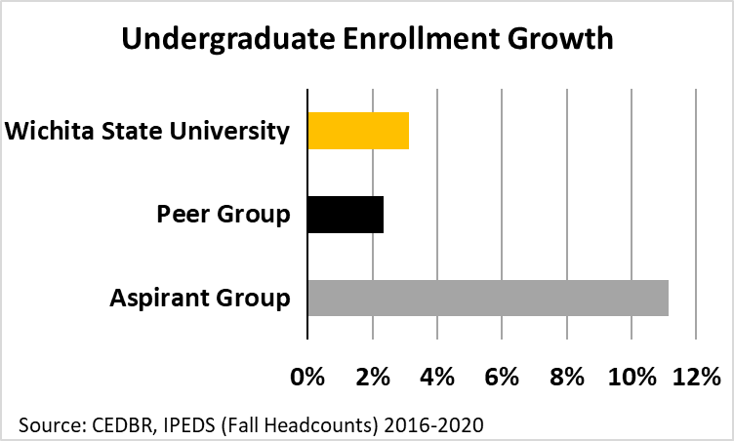

Population Growth
 | 2016-2020 | 2010-2020
Wichita State University | 1.64% | 4.51%
Peer Group | 5.36% | 11.51%
Cleveland State University | 0.02% | -0.04%
Portland State University | 6.58% | 13.20%
University of Memphis | 0.92% | 3.93%
University of Nebraska at Omaha | 4.31% | 11.15%
University of Texas at San Antonio | 7.64% | 18.57%
Aspirant Group | 5.33% | 12.34%
Georgia State University | 5.95% | 12.79%
University of California-Riverside | 4.50% | 9.62%
University of Cincinnati | 2.25% | 5.01%
University of Houston | 7.37% | 19.48%
University of North Carolina at Charlotte | 10.26% | 21.36%
Source: CEDBR, IPEDS (Fall Headcount), ESRI (30-Mile Radii)

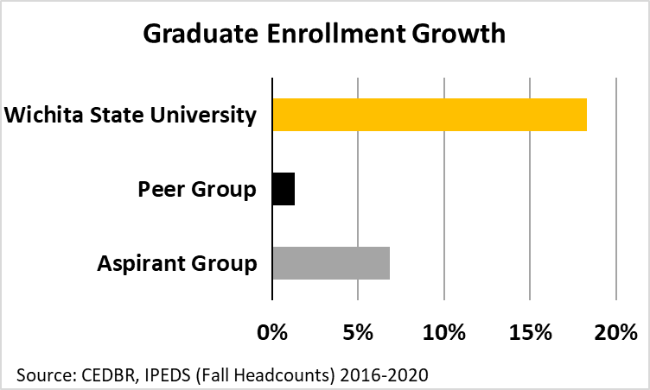
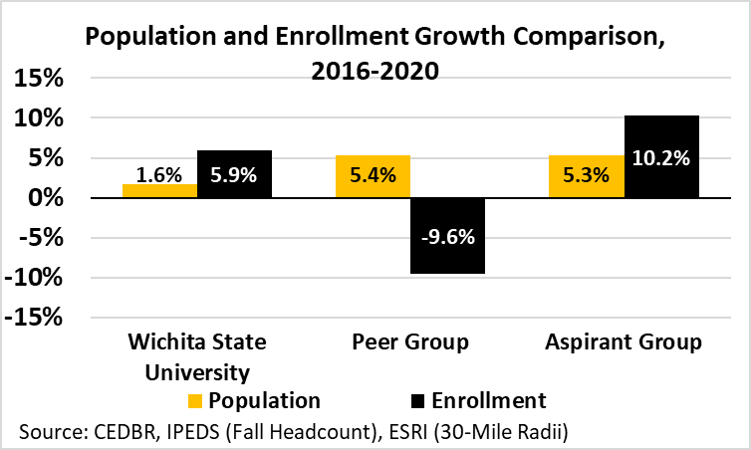

Enrollment growth at Wichita State University differed significantly by full-and-part-time status. For example, there was a notable decline in full-time enrollment, which was counterweighted by a dramatic increase in part-time enrollment, particularly among graduate students. Much of this change is attributable to the impact of the coronavirus pandemic. From the fall of 2020 to the fall of 2021, full-time enrollment rebounded, particularly among graduates, who had the greatest likelihood of attending part-time in 2020. Strong growth across most cohorts between 2020 and 2021 indicates Wichita State University is recovering strongly from the negative coronavirus impact.
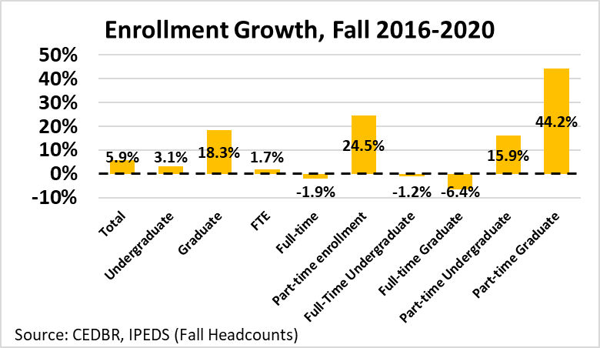

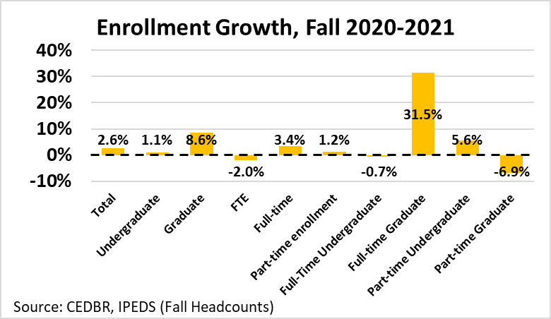

Student age
One of the WSU student body's most unique characteristics compared to its peers and aspirants is the relatively high percentage of students older than 25. Approximately 26% of WSU undergraduate students were over 25 in 2016, with a majority of those between the ages of 25 and 34. Conversely, WSU had the lowest share of students under 25 of its peers or aspirants in 2016. The growth in WSU's share of students younger than 25 was among the lowest, though the share of undergraduates over 25 declined 1.3 percentage points in the fall of 2020.

Share of Undergraduates 25 and Over - 2020
Wichita State University | 24.7%
Peer Group | 22.2%
Cleveland State University | Unavailable
Portland State University | 34.9%
University of Memphis | 19.7%
University of Nebraska at Omaha | 20.3%
University of Texas at San Antonio | 16.4%
Aspirant Group | 12.2%
Georgia State University | 15.6%
University of California-Riverside | 6.7%
University of Cincinnati | 10.3%
University of Houston | 13.8%
University of North Carolina at Charlotte | 12.4%
Source: CEDBR, IPEDS (Fall Headcount)

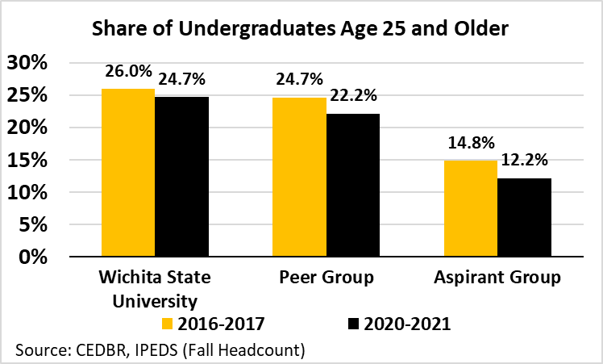
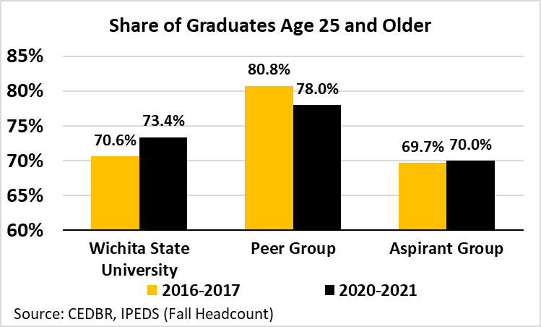

Did You Know?
Students have access to the largest engineering co-op and internship program in the state, gaining real-world experience-and careerswith NASA, NetApp, Spirit AeroSystem s, Toyota, Airbus, GE Aviation and others.

The unique nature of WSU having a higher concentration of undergraduates over the age of 25, is not reflected by the composition of the regional community. The share of persons who fall into Generation Z and Alpha was higher than its Peer Group and similar to its Aspirant Group. Conversely, Wichita had a lower relative concentration in Generation Z compared to both groups. Therefore, the university's concentration of older students reflects more on how it is interconnected with the development of the existing labor market. WSU has played a crucial role in serving businesses in developing and improving human capital, which is part of the university's deep history of being urban-serving.

Population of Generation Z
 | Count* | Share
Wichita State University | 152,699 | 24.0%
Peer Group | 426,887 | 22.6%
Cleveland State University | 479,891 | 20.8%
Portland State University | 548,005 | 21.6%
University of Memphis | 295,282 | 23.40%
University of Nebraska at Omaha | 235,341 | 23.9%
University of Texas at San Antonio | 575,918 | 24.5%
Aspirant Group | 957,308 | 24.3%
Georgia State University | 1,137,798 | 23.6%
University of California-Riverside | 1,054,853 | 25.0%
University of Cincinnati | 485,907 | 23.2%
University of Houston | 1,544,958 | 24.9%
University of North Carolina at Charlotte | 563,026 | 23.4%
Source: CEDBR, ESRI (30-Mile Radii)

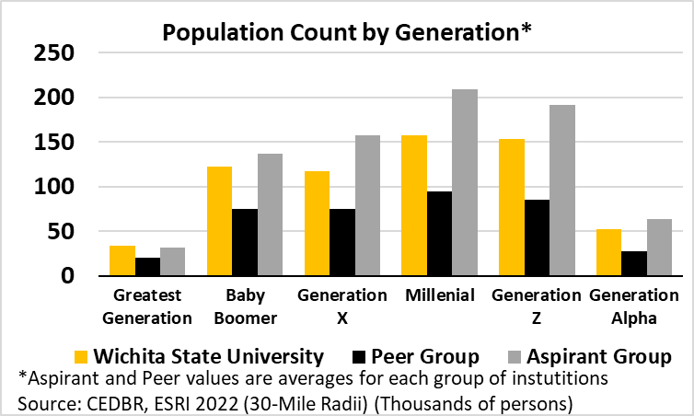

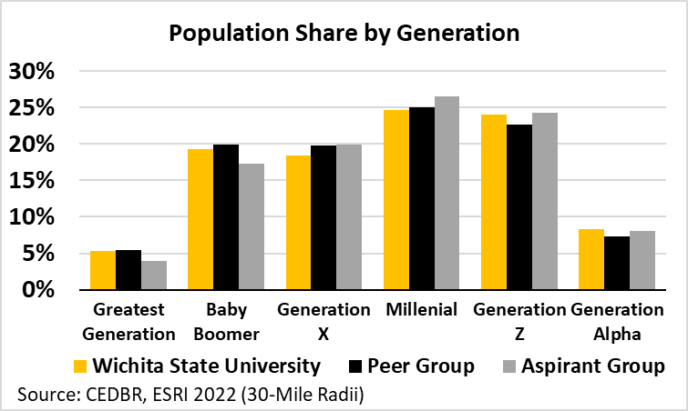

Industry and occupation
The regional economy surrounding WSU includes deep roots in aerospace manufacturing, energy production, and agriculture. The regional economy's share of employment within manufacturing was more than double that of four of the ten other comparable markets, with none having equivalent overall shares. Wichita State University and WSU Tech both provide educational pipelines to support the regional aerospace industry cluster, which includes engineering, supply chain management, welding, machining, and robotics.

Employment Share - 2022
University | Manufacturing | Services
Wichita State University | 17.9% | 14.9%
Peer Group
Cleveland State University | 13.9% | 15.3%
Portland State University | 11.5% | 14.6%
University Memphis | 9.4% | 15.7%
University Nebraska - Omaha | 7.9% | 13.7%
University Texas - San Antonio | 5.5% | 16.9%
Aspirant Group
Georgia State University | 7.0% | 13.2%
University California-Riverside | 8.9% | 15.7%
University Cincinnati | 12.8% | 14.2%
University Houston | 9.3% | 14.6%
University North Carolina - Charlotte | 9.9% | 13.8%
Source: CEDBR, ESRI 2022 (30-Mile Radii)

The manufacturing cluster translates to a high concentration of blue-collar jobs like avionics technicians, aircraft mechanics, tool and die makers, and coating and painting operators, all supported by WSU Tech. Although it might not be evident to someone living outside of the region, the industry also provides several white-collar jobs: aerospace engineers, computer programmers, space scientists, and industrial engineers, all of which align with the pipeline of degrees offered by the university, though overall the region has the third lowest share of white-collar occupations compared to Peer or Aspirant institutions.

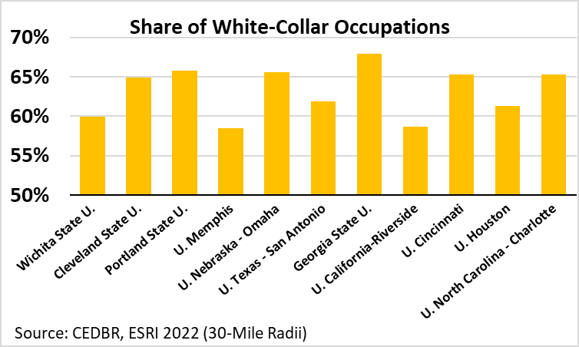
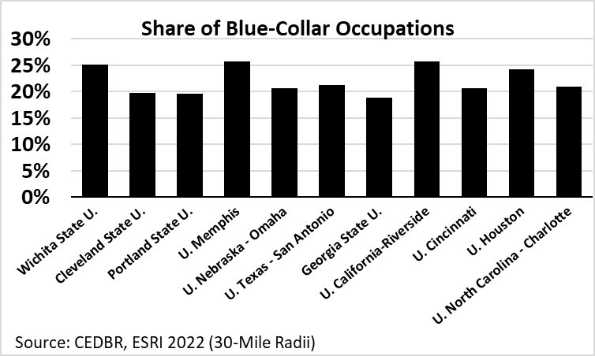

Did You Know?
WSU's main campus has grown by 120 acres. Enrollment has grown through geographic, online and curricular expansion. And community impact and visibility has increased through new locations and a GED-to-Ph.D. affiliation with the largest technical college in Kansas, rebranded as WSU Tech.

Diversity
Did You Know?
The WSU psychology clinic provides an average of 1,824 hours of therapy every year as well as an average of 582 hours of psychological assessment. In the past five years, the psychology department clinic has generated $81,199.83, while treating underserved populations on a heavily fee reduced sliding scale that includes pro bono work.

Wichita State's student body has continued to become more diverse from fall 2010 to fall 2020. Wichita State had one of the most significant increases in its share of female students, with an increase of 2.7 percentage points overall, 1.6 percentage points among undergraduate students, and 6.6 percentage points among graduate students. In comparison, WSU's female student body grew faster than both the Aspirant and Peer groups, particularly among graduate students.

Share of Total Female Enrollment - 2020
Wichita State University |  | 57.1%
Peer Group |  | 56.3%
Cleveland State University |  | 56.9%
Portland State University |  | 57.6%
University Memphis |  | 61.2%
University Nebraska - Omaha |  | 56.2%
University Texas - San Antonio |  | 52.0%
Aspirant Group |  | 54.1%
Georgia State University |  | 60.8%
University California-Riverside |  | 52.7%
University Cincinnati |  | 54.7%
University Houston |  | 51.6%
University North Carolina - Charlotte |  | 50.1%
Source: CEDBR, IPEDS (12-Month Unduplicated Headcounts)

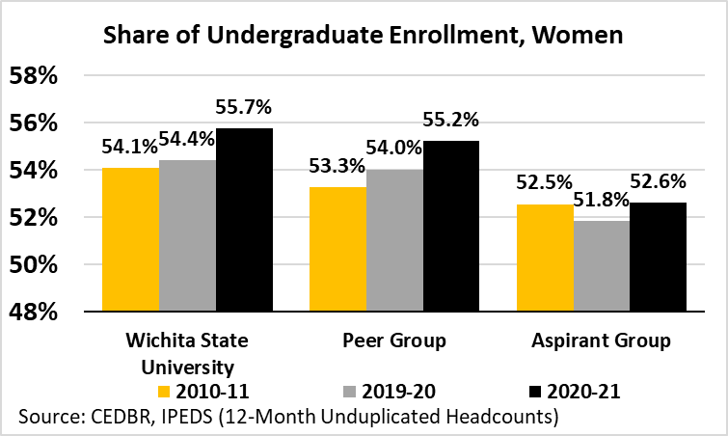

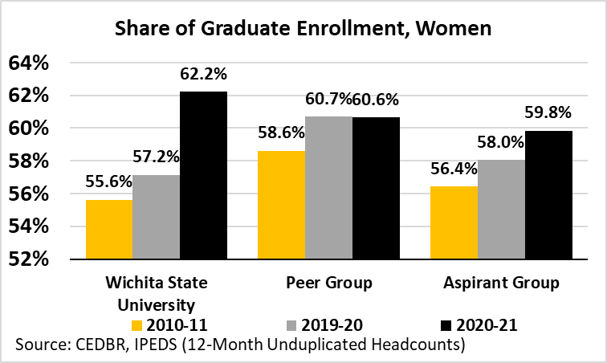

Did You Know?
WSU's focus on applied learning is a differentiator. Graduates have often worked in their chosen industry during their time on campus so they enter the workforce better prepared. Or, they have the knowledge to start their own business.

Eight of ten Peer and Aspirant universities have a higher share of minorities within the student body, with only the University of Nebraska – Omaha and the University of Cincinnati having lower representation, which maps precisely to the share of minorities within the local populace. At a radius of 30 miles, Wichita ranks eighth most diverse, with only those same two universities having lower minority representation. Of all racial groups, the largest representation in the Wichita State University student body and the local population was persons identifying as black alone, comprising 5.5% of enrollment and 7.7% of the local population. Persons of Hispanic origin account for 6.0% of WSU's student body and 14.5% of the local population. Specific Peer and Aspirant universities have a much greater level of these same minority identifications, with the University of Memphis' local population being over 45% black and the University of Texas-San Antonio and the University of California-Riverside having populations with over 40% Hispanic origin.

Diversity in Local Population - 2022
 | Minority Share | Diversity Index
Wichita State University | 29.2% | 60.5
Peer Group
Cleveland State University | 31.7% | 56.3
Portland State University | 29.7% | 62.4
University Memphis | 58.9% | 66.5
University Nebraska - Omaha | 26.0% | 55.6
University Texas - San Antonio | 52.8% | 83.8
Aspirant Group
Georgia State University | 62.0% | 76.3
University California-Riverside | 63.9% | 87.7
University Cincinnati | 25.2% | 46.7
University Houston | 63.5% | 88.3
University North Carolina - Charlotte | 41.8% | 68.9
*Diversity Index of 100 = equally diverse across all groups
Source: CEDBR, ESRI 2022 (30-Mile Radii)

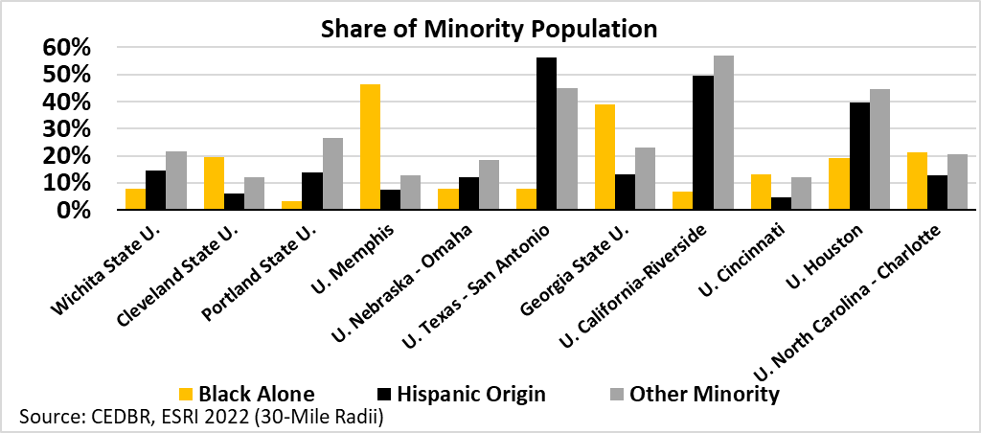

The distinct advantage possessed by Wichita State University compared to its peers is in the rate of growth of minority representation in the student body. WSU's minority students grew from 14.4% to 16.4% of the student body. The fastest growth was seen among Hispanic students, who increased from 5.8% to 11.7% of the student body by fall 2020. Though racial and ethnic diversity remains lower than the Peer and Aspirant Groups, growth compared to the share within the population and the change over time at WSU indicate it is becoming more diverse at an unrivaled rate. Furthermore, the Hispanic Association of Colleges & Universities identified Wichita State University as an Emerging Hispanic-Serving Institution.

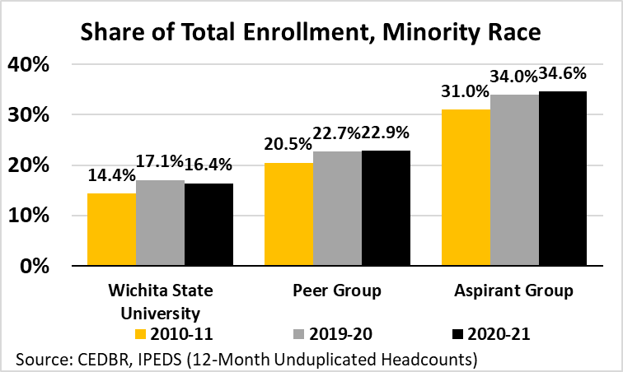

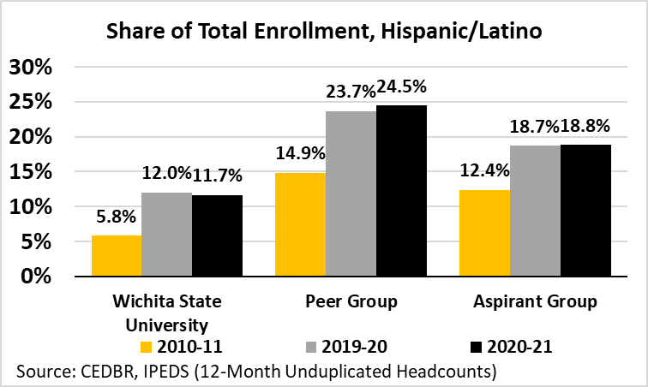

Cost and affordability

Did You Know?
From January 1 through September 2022, the Delta Dental of Kansas Dental Hygiene Clinic provided 3,523 dental hygiene appointments to persons from the Wichita and surrounding area. Most patients do not have insurance and benefit economically from the reduced fees for dental hygiene services at the clinic.

The total annual attendance price, including tuition and housing costs, rose at every university from 2016 to 2021. Among in-state, on-campus students, WSU's price increased by 16.5%, compared to the 12.1% growth in Peer price and 5.8% increase in Aspirant prices. Even after these price increases, WSU had a lower total cost than its Peer and Aspirant Group averages for both in- and out-of-state students living either on or off-campus.

Total Price for In-State Students - 2021
Wichita State University | $26,060
Peer Group | $26,353
Cleveland State University | $30,179
Portland State University | $28,296
University of Memphis | $26,429
University of Nebraska at Omaha | $23,388
University of Texas at San Antonio | $23,474
Aspirant Group | $29,022
Georgia State University | $30,834
University of California-Riverside | $36,460
University of Cincinnati | $29,024
University of Houston | $25,077
University of North Carolina at Charlotte | $23,716
Source: CEDBR, IPEDS (On-Campus Students)

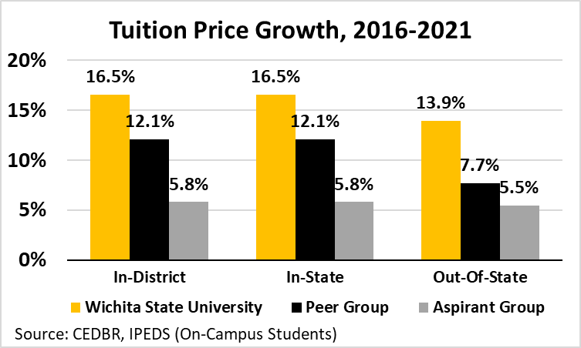

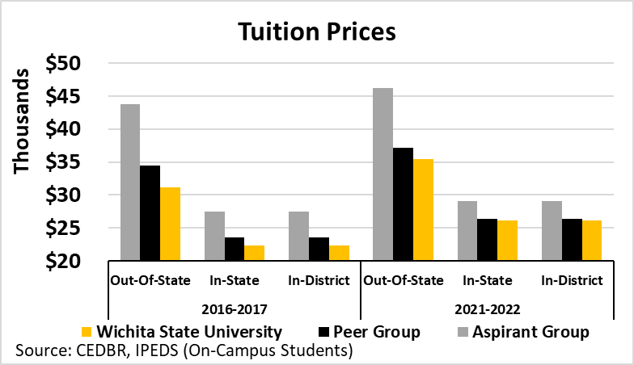

The average cost of living within a community is important in understanding the expected budget expenses while pursuing a college degree. A lower cost of living indicates that the costs are relatively lower for the same level of living standards. Wichita's cost of living was lower than nine of the ten locations, only having higher costs than the Memphis area. Housing costs were the key factor for lower costs within the 30-mile radius of Wichita State University. When looking at rented dwellings in Wichita, one of the highest costs for college students, the price was lower than all locations in both groups. Between the lower tuition price and lower cost of living, WSU and its surrounding area provide an affordable option to get a college degree from an accredited university compared to the Peer and Aspirant Groups.

Cost of Living Relative to Wichita - 2022
Peer Group | -8.1%
Cleveland State University | -5.2%
Portland State University | -31.3%
University of Memphis | 3.4%
University of Nebraska at Omaha | -5.0%
University of Texas at San Antonio | -2.2%
Aspirant Group | -16.1%
Georgia State University | -14.6%
University of California-Riverside | -42.0%
University of Cincinnati | -6.2%
University of Houston | -5.3%
University of North Carolina at Charlotte | -12.6%
Source: CEDBR, COLI Index Q2 2022

Cost of Living Relative to Wichita
 | Grocery | Housing | Utilities | Transportation | Healthcare
Peer Group
Cleveland State University | -6.0% | -17.3% | 2.0% | -0.8% | -6.1%
Portland State University | -11.3% | -59.9% | 8.4% | -24.1% | -11.8%
University of Memphis | 6.6% | -12.2% | 9.8% | 5.6% | 12.3%
University of Nebraska at Omaha | 0.0% | -21.7% | 3.4% | -7.8% | -0.9%
University of Texas at San Antonio | 10.2% | -16.5% | 11.2% | -2.1% | -1.3%
Aspirant Group
Georgia State University | 0.3% | -38.8% | 15.0% | -8.7% | -8.8%
University of California-Riverside | -13.7% | -71.5% | -9.7% | -25.8% | -14.0%
University of Cincinnati | -2.4% | -17.5% | 9.1% | -13.3% | -1.7%
University of Houston | 1.8% | -19.2% | -4.9% | -0.1% | -2.1%
University of North Carolina at Charlotte | -3.9% | -27.6% | 5.0% | -11.6% | -13.2%
Source: CEDBR, COLI Index Q2 2022

Rented Dwellings
 | Rent | Renters' Insurance | Maintenance and Repair Services | Maintenance and Repair Materials
Wichita State University | $4,851.95 | $34.45 | $62.68 | $27.93
Peer Group | $5,945.65 | $39.79 | $69.57 | $31.38
Cleveland State University | $5,081.86 | $35.73 | $65.04 | $28.52
Portland State University | $7,640.58 | $47.38 | $87.10 | $37.66
University of Memphis | $5,521.71 | $38.52 | $62.21 | $30.20
University of Nebraska at Omaha | $5,726.94 | $39.64 | $70.70 | $31.04
University of Texas at San Antonio | $5,757.18 | $37.68 | $62.81 | $29.46
Aspirant Group | $6,720.69 | $43.04 | $77.73 | $34.78
Georgia State University | $7,606.06 | $48.94 | $80.03 | $37.09
University of California-Riverside | $6,839.46 | $38.70 | $86.05 | $34.68
University of Cincinnati | $5,770.18 | $40.11 | $72.93 | $32.43
University of Houston | $7,183.66 | $45.04 | $74.43 | $34.74
University of North Carolina at Charlotte | $6,204.10 | $42.41 | $75.21 | $34.94
Source: CEDBR, ESRI, BLS - Consumer Expenditure Surveys

Financial aid and need
Between the fall of 2016 and the fall of 2020, the share of first-time undergraduates who received Pell Grants declined, opposite of the trend for students who received any federal, state, local, or institutional aid. The Federal Pell Grant program is used to help those who have a high degree of unmet financial need. Pell Grant recipients declined by 0.2% at WSU to 35.3% in fall 2020, a rate lower than its Peer Group but comparable to the average among the Aspirant Group, though the latter had a wide disparity across its component institutions. WSU's average undergraduate student receiving a Pell Grant grew 6.4 percentage points since 2016 to $4,676, which was slightly less than the average growth among its Peers and Aspirants. The share receiving any federal, state, local, or institutional aid increased from 79.0 to 79.3%, a share lower than that of its Peer and Aspirant Groups. The average amount awarded grew by 5.9% to $6,159, lower than average awards in Peer and Aspirant Groups. The lower amounts awarded at WSU were expected, considering the greater affordability of attendance described in the previous section, as the amount necessary to cover costs at WSU was notably lower than its Peers and Aspirants.

Pell Grants - 2019-20
Wichita State University | 35.3%
Peer Group | 47.6%
Cleveland State University | 46.9%
Portland State University | 53.6%
University of Memphis | 52.0%
University of Nebraska at Omaha | 40.3%
University of Texas at San Antonio | 46.4%
Aspirant Group | 36.1%
Georgia State University | 50.7%
University of California-Riverside | 47.0%
University of Cincinnati | 17.4%
University of Houston | 43.6%
University of North Carolina at Charlotte | 30.9%
Source: CEDBR, IPEDS (Fall Headcounts) full-time first-time undergraduates

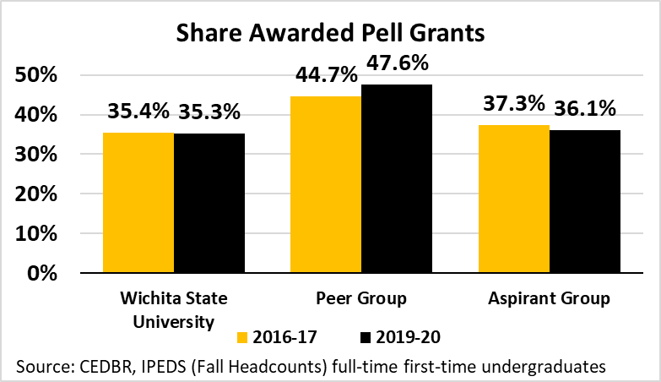

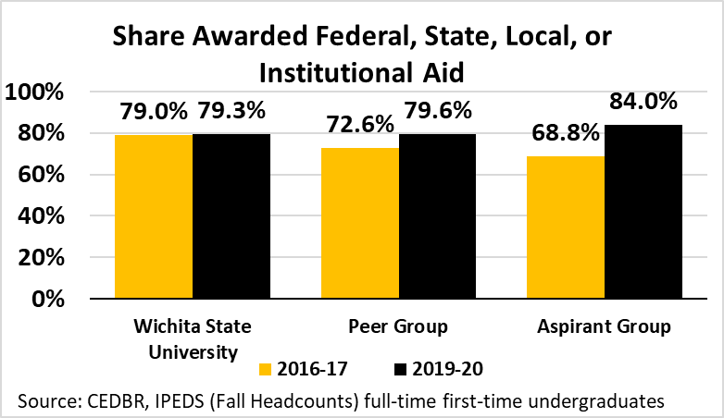

Household Income Less than $25,000
 | Share | Number
Wichita State University | 15.3% | 37,919
Peer Group
Cleveland State University | 18.8% | 185,724
Portland State University | 10.8% | 106,402
University of Memphis | 19.1% | 93,554
University of Nebraska at Omaha | 13.4% | 51,149
University of Texas at San Antonio | 15.9% | 135,322
Aspirant Group
Georgia State University | 12.2% | 221,837
University of California-Riverside | 11.2% | 144,515
University of Cincinnati | 15.8% | 131,264
University of Houston | 14.0% | 306,691
University of North Carolina at Charlotte | 12.4% | 116,033
Source: CEDBR, ESRI, Census ACS 30-Mile Radii

Income - 2022
 | Household Income |  | Per-Capita Income
Wichita State University | $64,882 |  | $34,801
Peer Group | $70,647 |  | $39,020
Cleveland State University | $61,843 |  | $39,383
Portland State University | $87,907 |  | $46,586
University of Memphis | $60,836 |  | $35,776
University of Nebraska at Omaha | $75,951 |  | $39,059
University of Texas at San Antonio | $66,700 |  | $34,295
Aspirant Group | $78,655 |  | $42,710
Georgia State University | $79,603 |  | $43,767
University of California-Riverside | $87,345 |  | $36,197
University of Cincinnati | $73,746 |  | $41,111
University of Houston | $75,704 |  | $49,046
University of North Carolina at Charlotte | $76,878 |  | $43,430
Source: CEDBR, ESRI, Census ACS 30-Mile Radii

Appendix

Faculty and Staff Headcounts
Faculty and Staff Headcount by State
State | Headcount | Share | Share Excluding Kansas
AZ | 4 | 0.2% | 3.4%
CA | 3 | 0.1% | 2.5%
CO | 6 | 0.2% | 5.1%
FL | 3 | 0.1% | 2.5%
GA | 2 | 0.1% | 1.7%
IA | 2 | 0.1% | 1.7%
IL | 1 | 0.0% | 0.8%
IN | 1 | 0.0% | 0.8%
KS | 2,415 | 95.3% | -
KY | 1 | 0.0% | 0.8%
MD | 1 | 0.0% | 0.8%
MI | 2 | 0.1% | 1.7%
MO | 16 | 0.6% | 13.6%
MS | 1 | 0.0% | 0.8%
NE | 4 | 0.2% | 3.4%
NJ | 2 | 0.1% | 1.7%
NM | 1 | 0.0% | 0.8%
NV | 2 | 0.1% | 1.7%
NY | 3 | 0.1% | 2.5%
OH | 1 | 0.0% | 0.8%
OK | 10 | 0.4% | 8.5%
OR | 1 | 0.0% | 0.8%
PA | 2 | 0.1% | 1.7%
SC | 1 | 0.0% | 0.8%
TN | 1 | 0.0% | 0.8%
TX | 15 | 0.6% | 12.7%
UT | 3 | 0.1% | 2.5%
VA | 1 | 0.0% | 0.8%
WA | 6 | 0.2% | 5.1%
WI | 1 | 0.0% | 0.8%
Unknown | 21 | 0.8% | 17.8%
Total | 2,533 | 100.0% | -
Total Excluding KS | 118 | - | 100.0%
Source: CEDBR, WSU, IPEDS 2022

Faculty and Staff Headcount by Kansas County
County | Headcount |  | Share |  | Share Excluding Sedgwick
Allen | 1 |  | 0.0% |  | 0.3%
Butler | 175 |  | 7.2% |  | 49.2%
Chase | 1 |  | 0.0% |  | 0.3%
Chautauqua | 1 |  | 0.0% |  | 0.3%
Coffey | 2 |  | 0.1% |  | 0.6%
Cowley | 11 |  | 0.5% |  | 3.1%
Crawford | 3 |  | 0.1% |  | 0.8%
Dickinson | 1 |  | 0.0% |  | 0.3%
Douglas | 8 |  | 0.3% |  | 2.2%
Ellis | 2 |  | 0.1% |  | 0.6%
Finney | 4 |  | 0.2% |  | 1.1%
Ford | 2 |  | 0.1% |  | 0.6%
Franklin | 1 |  | 0.0% |  | 0.3%
Geary | 3 |  | 0.1% |  | 0.8%
Gray | 1 |  | 0.0% |  | 0.3%
Greenwood | 2 |  | 0.1% |  | 0.6%
Harper | 1 |  | 0.0% |  | 0.3%
Harvey | 45 |  | 1.9% |  | 12.6%
Johnson | 8 |  | 0.3% |  | 2.2%
Kingman | 7 |  | 0.3% |  | 2.0%
Labette | 1 |  | 0.0% |  | 0.3%
Lyon | 1 |  | 0.0% |  | 0.3%
Marion | 9 |  | 0.4% |  | 2.5%
Marshall | 1 |  | 0.0% |  | 0.3%
McPherson | 4 |  | 0.2% |  | 1.1%
Miami | 1 |  | 0.0% |  | 0.3%
Montgomery | 1 |  | 0.0% |  | 0.3%
Morris | 1 |  | 0.0% |  | 0.3%
Reno | 8 |  | 0.3% |  | 2.2%
Rice | 2 |  | 0.1% |  | 0.6%
Riley | 5 |  | 0.2% |  | 1.4%
Rooks | 1 |  | 0.0% |  | 0.3%
Saline | 6 |  | 0.2% |  | 1.7%
Sedgwick | 2,059 |  | 85.3% |  | -
Shawnee | 5 |  | 0.2% |  | 1.4%
Sumner | 24 |  | 1.0% |  | 6.7%
Wabaunsee | 1 |  | 0.0% |  | 0.3%
Wyandotte | 6 |  | 0.2% |  | 1.7%
Total | 2,415 |  | 100.0% |  | -
Total Excluding Sedgwick | 356 |  | - |  | 100.0%
Source: CEDBR, WSU, IPEDS 2022

Economic Contribution - Wichita State University
Wichita State University - Economic Contribution
 | Employment | Labor Income | Output
Direct Effect | 5,553 | $316,169,470 | $562,285,707
Indirect Effect | 1051 | $51,843,038 | $178,059,858
Induced Effect | 1,785 | $84,135,748 | $277,370,270
Total Effect | 8,389 | $452,148,254 | $1,017,715,835
Wichita State University - Employment Contribution
 | Direct | Indirect | Induced | Total
Total | 5552.7 | 1051.3 | 1784.5 | 8388.6
Agriculture | 0.2 | 4 | 5.9 | 10.1
Mining | 0 | 4 | 6.4 | 10.4
Construction | 0 | 29.8 | 13.5 | 43.4
Manufacturing | 0 | 15.6 | 14.7 | 30.4
TIPU | 0 | 180.5 | 79.1 | 259.6
Trade | 2254.3 | 33 | 353.4 | 2640.5
Service | 3289.8 | 763.9 | 1296.8 | 5350.4
Government | 8.5 | 20.6 | 14.7 | 43.9
Wichita State University - Labor Income Contribution
 | Direct | Indirect | Induced | Total
Total | $316,169,470 | $51,843,038 | $84,135,748 | $452,148,254
Agriculture | $10,309 | $129,171 | $172,628 | $312,107
Mining | $0 | $112,231 | $154,419 | $266,650
Construction | $0 | $1,726,164 | $772,606 | $2,498,772
Manufacturing | $0 | $930,540 | $998,729 | $1,929,270
TIPU | $582 | $11,490,474 | $6,329,518 | $17,820,575
Trade | $67,535,117 | $2,049,460 | $12,559,966 | $82,144,542
Service | $247,970,034 | $33,683,143 | $61,943,768 | $343,596,944
Government | $653,428 | $1,721,854 | $1,204,115 | $3,579,395
Wichita State University - Output Contribution
 | Direct | Indirect | Induced | Total
Total | $562,285,707 | $178,059,858 | $277370270 | $1,017,715,835
Agriculture | $68,803 | $801,403 | $955492 | $1,825,698
Mining | $0 | $1,197,030 | $1933702 | $3,130,731
Construction | $0 | $6,254,132 | $2848270 | $9,102,402
Manufacturing | $0 | $6,867,229 | $10984589 | $17,851,818
TIPU | $1,382 | $41,818,259 | $23858417 | $65,678,058
Trade | $194,009,798 | $7,112,236 | $40583409 | $241,705,443
Service | $365,182,916 | $108,332,046 | $192436854 | $665,951,817
Government | $3,022,807 | $5,677,525 | $3769538 | $12,469,868
*Excludes capital expenditures
Source: CEDBR

Economic Contribution - WSU Tech
WSU Tech - Economic Contribution
 | Employment | Labor Income | Output
Direct Effect | 1,279 | $39,165,167 | $100,299,021
Indirect Effect | 175 | $9,415,099 | $29,999,790
Induced Effect | 236 | $11,107,161 | $36,614,233
Total Effect | 1,689 | $59,687,427 | $166,913,044
WSU Tech - Employment Contribution
 | Direct | Indirect | Induced | Total
Total | 1,279 | 175 | 236 | 1,689
Agriculture | 0 |  | 1 | 1
Mining | 0 | 1 | 1 | 1
Construction | 0 | 7 | 2 | 9
Manufacturing | 0 | 2 | 2 | 4
TIPU | 0 | 42 | 10 | 53
Trade | 633 | 6 | 47 | 685
Service | 643 | 114 | 171 | 928
Government | 3 | 3 | 2 | 7
WSU Tech - Labor Income Contribution
 | Direct | Indirect | Induced | Total
Total | $39,165,167 | $9,415,099 | $11,107,161 | $59,687,427
Agriculture | $0 | $12,093 | $22,777 | $34,869
Mining | $0 | $18,640 | $20,370 | $39,010
Construction | $0 | $393,807 | $101,993 | $495,800
Manufacturing | $0 | $131,195 | $131,766 | $262,961
TIPU | $171 | $2,525,984 | $835,139 | $3,361,293
Trade | $18,974,059 | $335,590 | $1,657,250 | $20,966,898
Service | $19,988,134 | $5,758,848 | $8,178,987 | $33,925,969
Government | $202,802 | $238,942 | $158,881 | $60,0625
WSU Tech - Output Contribution
 | Direct | Indirect | Induced | Total
Total | $100,299,021 | $29,999,790 | $36,614,233 | $166,913,044
Agriculture | $0 | $59,325 | $126,060 | $185,385
Mining | $0 | $185,007 | $255,074 | $440,081
Construction | $0 | $1,452,416 | $376,008 | $1,828,424
Manufacturing | $0 | $933,724 | $1,448,980 | $2,382,705
TIPU | $406 | $8,507,534 | $3,147,831 | $11,655,770
Trade | $54,227,763 | $1,189,565 | $5,354,842 | $60,772,171
Service | $45,129,623 | $16,971,398 | $25,408,207 | $87,509,227
Government | $941,229 | $700,821 | $497,231 | $2,139,281
*Excludes capital expenditures
Source: CEDBR

Economic Contribution - Research
Research - Economic Contribution
 | Employment | Labor Income | Output
Direct Effect | 652 | $52,548,336 | $104,964,351
Indirect Effect | 179 | $7,813,793 | $32,617,262
Induced Effect | 293 | $13,800,027 | $45,494,899
Total Effect | 1,123 | $74,162,156 | $183,076,512
Research - Employment Contribution
 | Direct | Indirect | Induced | Total
Total | 652 | 178.6 | 292.7 | 1123.3
Agriculture | 0 | 1.4 | 1 | 2.3
Mining | 0 | 0.9 | 1 | 2
Construction | 0 | 3.5 | 2.2 | 5.7
Manufacturing | 0 | 3.5 | 2.4 | 5.9
TIPU | 0 | 12 | 13 | 25
Trade | 0 | 5.5 | 58 | 63.5
Service | 652 | 146.3 | 212.7 | 1011
Government | 0 | 5.5 | 2.4 | 7.9
Research - Labor Income Contribution
 | Direct | Indirect | Induced | Total
Total | $52,548,336 | $7,813,793 | $13,800,027 | $74,162,156
Agriculture | $0 | $44,339 | $28,316 | $72,655
Mining | $0 | $24,095 | $25,330 | $49,425
Construction | $0 | $210,111 | $126,724 | $336,835
Manufacturing | $0 | $212,545 | $163,823 | $376,369
TIPU | $0 | $1,083,970 | $1,038,233 | $2,122,202
Trade | $0 | $393,761 | $2,060,209 | $2,453,970
Service | $52,548,336 | $5,405,855 | $10,159,881 | $68,114,072
Government | $0 | $439,117 | $197,510 | $636,628
Research - Output Contribution
 | Direct | Indirect | Induced | Total
Total | $104,964,351 | $32,617,262 | $45,494,899 | $183,076,512
Agriculture | $0 | $315,502 | $156,731 | $472,234
Mining | $0 | $277,282 | $317,194 | $594,476
Construction | $0 | $724,243 | $467,177 | $1,191,419
Manufacturing | $0 | $1,691,660 | $1,801,853 | $3,493,513
TIPU | $0 | $5,191,531 | $3,913,520 | $9,105,051
Trade | $0 | $1,303,841 | $6,656,892 | $7,960,733
Service | $104,964,351 | $21,395,323 | $31,563,196 | $157,922,870
Government | $0 | $1,717,881 | $618,336 | $2,336,217
*Excludes capital expenditures
Source: CEDBR

Economic Contribution - Board of Trustees
Board of Trustees - Economic Contribution
 | Employment | Labor Income | Output
Direct Effect | 0 | $34,264 | $3,201,774
Indirect Effect | 5.4 | $238,348 | $994,939
Induced Effect | 1.3 | $62,373 | $205,421
Total Effect | 6.8 | $334,985 | $4,402,134
Board of Trustees - Employment Contribution
 | Direct | Indirect | Induced | Total
Total | 0 | 5.4 | 1.3 | 6.8
Agriculture | 0 | 0 | 0 | 0
Mining | 0 | 0 | 0 | 0
Construction | 0 | 0.1 | 0 | 0.1
Manufacturing | 0 | 0.1 | 0 | 0.1
TIPU | 0 | 0.4 | 0.1 | 0.4
Trade | 0 | 0.2 | 0.3 | 0.4
Service | 0 | 4.5 | 1 | 5.4
Government | 0 | 0.2 | 0 | 0.2
Board of Trustees - Labor Income Contribution
 | Direct | Indirect | Induced | Total
Total | $34,264 | $238,348 | $62,373 | $334,985
Agriculture | $0 | $1,352 | $127 | $1,480
Mining | $0 | $735 | $113 | $848
Construction | $0 | $6,409 | $573 | $6,982
Manufacturing | $0 | $6,483 | $734 | $7,218
TIPU | $0 | $33,065 | $4,659 | $37,723
Trade | $0 | $12,011 | $9,248 | $21,259
Service | $34,264 | $164,897 | $46,033 | $245,194
Government | $0 | $13,395 | $887 | $14,281
Board of Trustees - Output Contribution
 | Direct | Indirect | Induced | Total
Total | $3,201,774 | $994,939 | $205,421 | $4,402,134
Agriculture | $0 | $9,624 | $702 | $10,326
Mining | $0 | $8,458 | $1,418 | $9,876
Construction | $0 | $22,092 | $2,111 | $24,203
Manufacturing | $0 | $51,601 | $8,058 | $59,659
TIPU | $0 | $158,360 | $17,551 | $175,910
Trade | $0 | $39,772 | $29,880 | $69,651
Service | $3,201,774 | $652,631 | $142,937 | $3,997,342
Government | $0 | $52,401 | $2,764 | $55,166
*Excludes capital expenditures
Source: CEDBR

Economic Contribution - Foundation
Foundation - Economic Contribution
 | Employment | Labor Income | Output
Direct Effect | 54 | $4,665,924 | $15,855,345
Indirect Effect | 38.9 | $2,003,315 | $5,467,789
Induced Effect | 32.3 | $1,524,830 | $5,026,504
Total Effect | 125.2 | $8,194,069 | $26,349,638
Foundation - Employment Contribution
 | Direct | Indirect | Induced | Total
Total | 54 | 38.9 | 32.3 | 125.2
Agriculture | 0 | 0 | 0.1 | 0.1
Mining | 0 | 0.1 | 0.1 | 0.2
Construction | 0 | 0.2 | 0.2 | 0.5
Manufacturing | 0 | 0.7 | 0.3 | 0.9
TIPU | 0 | 3.7 | 1.4 | 5.1
Trade | 0 | 1 | 6.4 | 7.4
Service | 54 | 32.6 | 23.5 | 110.1
Government | 0 | 0.5 | 0.3 | 0.8
Foundation - Labor Income Contribution
 | Direct | Indirect | Induced | Total
Total | $4,665,924 | $2,003,315 | $1,524,830 | $8,194,069
Agriculture | $0 | $344 | $3,127 | $3,471
Mining | $0 | $2,249 | $2,796 | $5,045
Construction | $0 | $13,424 | $14,002 | $27,426
Manufacturing | $0 | $37,331 | $18,088 | $55,420
TIPU | $0 | $251,732 | $114,646 | $366,379
Trade | $0 | $64,245 | $227,505 | $291,750
Service | $4,665,924 | $1,588,780 | $1,122,854 | $7,377,558
Government | $0 | $45,209 | $21,811 | $67,020
Foundation - Output Contribution
 | Direct | Indirect | Induced | Total
Total | $15,855,345 | $5,467,789 | $5,026,504 | $26,349,638
Agriculture | $0 | $1,671 | $17,305 | $18,976
Mining | $0 | $27,267 | $35,015 | $62,283
Construction | $0 | $46,187 | $51,620 | $97,806
Manufacturing | $0 | $218,849 | $198,910 | $417,759
TIPU | $0 | $950,346 | $432,128 | $1,382,473
Trade | $0 | $232,145 | $735,105 | $967,250
Service | $15,855,345 | $3,911,434 | $3,488,164 | $23,254,943
Government | $0 | $79,890 | $68,258 | $148,147
*Excludes capital expenditures
Source: CEDBR

Economic Contribution - Athletics
Athletics - Economic Contribution
 | Employment | Labor Income | Output
Direct Effect | 302.5 | $17,437,533 | $21,146,390
Indirect Effect | 92.1 | $3,266,485 | $11,025,447
Induced Effect | 100.4 | $4,733,153 | $15,604,806
Total Effect | 494.9 | $25,437,172 | $47,776,644
Athletics - Employment Contribution
 | Direct | Indirect | Induced | Total
Total | 302.5 | 92.1 | 100.4 | 494.9
Agriculture | 0.2 | 0.3 | 0.4 | 0.7
Mining | 0 | 0.1 | 0.4 | 0.5
Construction | 0 | 0.6 | 0.8 | 1.2
Manufacturing | 0 | 0.8 | 0.8 | 1.7
TIPU | 0 | 7.6 | 4.5 | 12.1
Trade | 50.6 | 1.8 | 19.9 | 72.2
Service | 251.6 | 80 | 73 | 404.6
Government | 0 | 1 | 0.8 | 1.8
Athletics - Labor Income Contribution
 | Direct | Indirect | Induced | Total
Total | $17,437,533 | $3,266,485 | $4,733,153 | $25,437,172
Agriculture | $8,291 | $8,222 | $9,716 | $26,229
Mining | $0 | $3,718 | $8,693 | $12,410
Construction | $0 | $31,050 | $43,465 | $74,515
Manufacturing | $0 | $50,690 | $56,215 | $106,905
TIPU | $27 | $472,065 | $356,243 | $828,335
Trade | $1,496,150 | $94,665 | $706,894 | $2,297,708
Service | $15,930,906 | $2,522,722 | $3,484,159 | $21,937,788
Government | $2,160 | $83,352 | $67,769 | $153,281
Athletics - Output Contribution
 | Direct | Indirect | Induced | Total
Total | $21,146,390 | $11,025,447 | $15,604,806 | $47,776,644
Agriculture | $55,331 | $41,115 | $53,782 | $150,228
Mining | $0 | $42,585 | $108,858 | $151,444
Construction | $0 | $106,868 | $160,235 | $267,102
Manufacturing | $0 | $341,678 | $618,380 | $960,058
TIPU | $65 | $1,807,941 | $1,342,867 | $3,150,873
Trade | $4,672,611 | $325,772 | $2,284,101 | $7,282,484
Service | $16,416,371 | $8,162,094 | $10,824,373 | $35,402,838
Government | $2,012 | $197,394 | $212,211 | $411,616
*Excludes capital expenditures
Source: CEDBR

Economic Contribution - Union (RSC)
Union (RSC) - Economic Contribution
 | Employment | Labor Income | Output
Direct Effect | 33 | $3,607,810 | $7,047,107
Indirect Effect | 12 | $672,317 | $2,470,399
Induced Effect | 20.8 | $978,982 | $3,225,494
Total Effect | 65.8 | $5,259,109 | $12,743,001
Union (RSC) - Employment Contribution
 | Direct | Indirect | Induced | Total
Total | 33 | 12 | 20.8 | 65.8
Agriculture | 0 | 0.1 | 0.1 | 0.1
Mining | 0 | 0.1 | 0.1 | 0.2
Construction | 0 | 0.4 | 0.2 | 0.6
Manufacturing | 0 | 0.5 | 0.2 | 0.7
TIPU | 0 | 1.1 | 0.9 | 2
Trade | 0 | 0.9 | 4.1 | 5
Service | 33 | 8.8 | 15.1 | 56.9
Government | 0 | 0.2 | 0.2 | 0.3
Union (RSC) - Labor Income Contribution
 | Direct | Indirect | Induced | Total
Total | $3,607,810 | $672,317 | $978,982 | $5,259,109
Agriculture | $0 | $2,790 | $2,000 | $4,790
Mining | $0 | $2,161 | $1,786 | $3,947
Construction | $0 | $24,233 | $8,988 | $33,221
Manufacturing | $0 | $31,158 | $11,564 | $42,722
TIPU | $0 | $109,315 | $73,333 | $182,649
Trade | $0 | $66,786 | $145,549 | $212,335
Service | $3,607,810 | $419,483 | $721,807 | $4,749,100
Government | $0 | $16,390 | $13,955 | $30,345
Union (RSC) - Output Contribution
Description | Direct | Indirect | Induced | Total
Total | $7,047,107 | $2,470,399 | $3,225,494 | $12,743,001
Agriculture | $0 | $15,842 | $11,063 | $26,905
Mining | $0 | $24,623 | $22,358 | $46,981
Construction | $0 | $83,341 | $33,138 | $116,479
Manufacturing | $0 | $232,174 | $127,012 | $359,186
TIPU | $0 | $586,538 | $276,329 | $862,867
Trade | $0 | $238,418 | $470,284 | $708,702
Service | $7,047,107 | $1,229,051 | $2,241,732 | $10,517,890
Government | $0 | $60,413 | $43,579 | $103,992
*Excludes capital expenditures
Source: CEDBR

Community Engagement and Comparison

Fall Enrollment - Undergraduates
 | Total |  | Male |  | Female
 | 2016 | 2020 | 2016 | 2020 | 2016 | 2020
Cleveland State University | 12,352 | 11,166 | 5,843 | 4,939 | 6,509 | 6,227
Georgia State University | 25,228 | 28,787 | 10,309 | 11,545 | 14,919 | 17,242
Portland State University | 21,071 | 18,656 | 9,908 | 8,196 | 11,163 | 10,460
The University of Texas at San Antonio | 24,724 | 29,959 | 12,363 | 14,608 | 12,361 | 15,351
University of California-Riverside | 19,799 | 22,693 | 9,263 | 10,493 | 10,536 | 12,200
University of Cincinnati-Main Campus | 25,820 | 29,933 | 12,999 | 14,903 | 12,821 | 15,030
University of Houston | 35,995 | 39,165 | 18,409 | 19,308 | 17,586 | 19,857
University of Memphis | 17,183 | 17,383 | 7,144 | 6,858 | 10,039 | 10,525
University of Nebraska at Omaha | 12,536 | 12,768 | 6,026 | 5,719 | 6,510 | 7,049
University of North Carolina at Charlotte | 23,404 | 24,175 | 12,322 | 12,873 | 11,082 | 11,302
Wichita State University | 11,585 | 11,946 | 5,420 | 5,276 | 6,165 | 6,670
Source: CEDBR, IPEDS (Fall Headcounts)

Fall Enrollment - Graduates
 | Total |  |  | Male |  | Female
 | 2016 |  | 2020 | 2016 | 2020 | 2016 | 2020
Cleveland State University | 4,512 |  | 4,081 | 1,900 | 1,631 | 2,612 | 2,450
Georgia State University | 7,009 |  | 7,573 | 2,772 | 2,801 | 4,237 | 4,772
Portland State University | 5,556 |  | 4,984 | 2,194 | 1,824 | 3,362 | 3,160
The University of Texas at San Antonio | 4,235 |  | 4,783 | 1,875 | 2,091 | 2,360 | 2,692
University of California-Riverside | 2,916 |  | 3,741 | 1,618 | 2,000 | 1,298 | 1,741
University of Cincinnati-Main Campus | 10,776 |  | 10,893 | 4,335 | 4,066 | 6,441 | 6,827
University of Houston | 7,779 |  | 7,925 | 3,842 | 3,556 | 3,937 | 4,369
University of Memphis | 4,118 |  | 4,822 | 1,683 | 1,810 | 2,435 | 3,012
University of Nebraska at Omaha | 3,091 |  | 3,124 | 1,245 | 1,194 | 1,846 | 1,930
University of North Carolina at Charlotte | 5,317 |  | 5,971 | 2,328 | 2,353 | 2,989 | 3,618
Wichita State University | 2,581 |  | 3,053 | 1,223 | 1,112 | 1,358 | 1,941
Source: CEDBR, IPEDS (Fall Headcounts)

Total Price
 | On Campus |  |  |  |  |  |  |  |  |  | Off-Campus
 | In-District |  |  |  | In-State |  |  |  | Out-Of-State |  | In-District |  | In-State |  |  | Out-Of-State
 | 2016-17 |  |  | 2021-22 | 2016-17 |  |  | 2021-22 | 2016-17 | 2021-22 | 2016-17 | 2021-22 | 2016-17 |  | 2021-22 | 2016-17 |  |  | 2021-22
Cleveland State University | $26,038 |  |  | $30,179 | $26,038 |  |  | $30,179 | $30,089 | $35,142 | $26,038 | $28,630 | $26,038 |  | $28,630 | $30,089 |  |  | $33,593
Georgia State University | $27,088 |  |  | $30,834 | $27,088 |  |  | $30,834 | $41,656 | $46,065 | $24,802 | $28,142 | $24,802 |  | $28,142 | $39,370 |  |  | $43,373
Portland State University | $24,087 |  |  | $28,296 | $24,087 |  |  | $28,296 | $40,602 | $47,196 | $26,327 | $28,296 | $26,327 |  | $28,296 | $42,842 |  |  | $47,196
The University of Texas at San Antonio | $22,372 |  |  | $23,474 | $22,372 |  |  | $23,474 | $32,969 | $35,771 | $22,924 | $25,631 | $22,924 |  | $25,631 | $33,521 |  |  | $37,928
University of California-Riverside | $34,391 |  |  | $36,460 | $34,391 |  |  | $36,460 | $61,073 | $66,214 | $29,622 | $32,312 | $29,622 |  | $32,312 | $56,304 |  |  | $62,066
University of Cincinnati-Main Campus | $27,966 |  |  | $29,024 | $27,966 |  |  | $29,024 | $43,300 | $44,358 | $30,268 | $30,420 | $30,268 |  | $30,420 | $45,602 |  |  | $45,754
University of Houston | $24,605 |  |  | $25,077 | $24,605 |  |  | $25,077 | $36,797 | $37,269 | $27,394 | $25,516 | $27,394 |  | $25,516 | $39,586 |  |  | $37,708
University of Memphis | $24,205 |  |  | $26,429 | $24,205 |  |  | $26,429 | $35,917 | $30,461 | $24,205 | $26,429 | $24,205 |  | $26,429 | $35,917 |  |  | $30,461
University of Nebraska at Omaha | $20,830 |  |  | $23,388 | $20,830 |  |  | $23,388 | $32,750 | $36,970 | $20,562 | $23,388 | $20,562 |  | $23,388 | $32,482 |  |  | $36,970
University of North Carolina at Charlotte | $23,110 |  |  | $23,716 | $23,110 |  |  | $23,716 | $36,281 | $37,150 | $21,282 | $23,716 | $21,282 |  | $23,716 | $34,453 |  |  | $37,150
Wichita State University | $22,362 |  |  | $26,060 | $22,362 |  |  | $26,060 | $31,101 | $35,425 | $24,239 | $24,209 | $24,239 |  | $24,209 | $32,978 |  |  | $33,574
Source: CEDBR - IPEDS

Financial Aid to All Undergraduate Students
 | Awarded Grants |  |  |  |  |  |  |  | Pell Grants
 | Share |  |  |  | Average Award |  |  |  | Share |  |  | Average Award
 | 2016-17 | 2019-20 |  |  | 2016-17 |  | 2019-20 |  | 2016-17 |  | 2019-20 | 2016-17 | 2019-20
Cleveland State University | 58% | 63% |  |  | $6,246 |  | $7,730 |  | 39% |  | 40% | $4,158 | $4,705
Georgia State University | 71% | 79% |  |  | $7,236 |  | $8,703 |  | 49% |  | 49% | $4,289 | $4,631
Portland State University | 49% | 54% |  |  | $6,317 |  | $7,423 |  | 38% |  | 39% | $3,994 | $4,446
The University of Texas at San Antonio | 66% | 75% |  |  | $7,377 |  | $7,561 |  | 43% |  | 45% | $4,205 | $4,439
University of California-Riverside | 81% | 91% |  |  | $17,363 |  | $16,159 |  | 56% |  | 51% | $4,482 | $4,961
University of Cincinnati-Main Campus | 60% | 78% |  |  | $7,099 |  | $5,311 |  | 22% |  | 20% | $4,098 | $4,701
University of Houston | 56% | 82% |  |  | $7,204 |  | $6,544 |  | 37% |  | 41% | $4,242 | $4,856
University of Memphis | 77% | 89% |  |  | $7,030 |  | $7,591 |  | 46% |  | 43% | $4,215 | $4,778
University of Nebraska at Omaha | 62% | 67% |  |  | $8,304 |  | $9,586 |  | 32% |  | 34% | $4,035 | $4,580
University of North Carolina at Charlotte | 51% | 51% |  |  | $6,628 |  | $7,347 |  | 37% |  | 36% | $4,153 | $4,827
Wichita State University | 60% | 64% |  |  | $4,859 |  | $5,276 |  | 34% |  | 32% | $3,875 | $4,350
Source: CEDBR, IPEDS (Fall Headcounts) full-time first-time undergraduates

Age Cohorts
 | Undergraduates |  |  |  |  |  |  |  |  | Graduates
 | Under 25 |  |  | 25 to 49 |  |  | 50 and Older |  |  | Under 25 |  |  | 25 to 49 |  |  | 50 and Older
 | 2016-17 |  | 2020-21 | 2016-17 | 2020-21 |  | 2016-17 | 2020-21 |  | 2016-17 |  | 2020-21 | 2016-17 |  | 2020-21 | 2016-17 |  | 2020-21
Cleveland State University | NA |  | NA | NA | NA |  | NA | NA |  | NA |  | NA | NA |  | NA | NA |  | NA
Georgia State University | 20,448 |  | 24,284 | 4,378 | 4,189 |  | 402 | 314 |  | 1,601 |  | 1,910 | 5,211 |  | 5,037 | 452 |  | 371
Portland State University | 12,891 |  | 12,141 | 7,782 | 6,249 |  | 345 | 263 |  | 782 |  | 595 | 4,068 |  | 4,400 | 321 |  | 372
The University of Texas at San Antonio | 20,843 |  | 25,035 | 3,741 | 4,754 |  | 140 | 170 |  | 969 |  | 1,395 | 3,140 |  | 3,040 | 248 |  | 226
University of California-Riverside | 18,912 |  | 21,169 | 857 | 1,497 |  | 30 | 27 |  | 867 |  | 1,134 | 2,544 |  | 1,983 | 63 |  | 66
University of Cincinnati-Main Campus | 22,285 |  | 26,851 | 3,179 | 2,837 |  | 356 | 245 |  | 3,339 |  | 3,358 | 7,147 |  | 7,032 | 388 |  | 405
University of Houston | 29,529 |  | 33,741 | 6,303 | 5,307 |  | 163 | 117 |  | 2,845 |  | 2,788 | 4,914 |  | 4,791 | 223 |  | 143
University of Memphis | 13,226 |  | 13,960 | 3,689 | 3,182 |  | 268 | 241 |  | 794 |  | 1,179 | 3,334 |  | 3,062 | 309 |  | 262
University of Nebraska at Omaha | 9,896 |  | 10,175 | 2,512 | 2,458 |  | 128 | 135 |  | 727 |  | 729 | 2,235 |  | 2,192 | 160 |  | 172
University of North Carolina at Charlotte | 19,851 |  | 21,179 | 3,393 | 2,865 |  | 160 | 131 |  | 1,610 |  | 1,649 | 3,979 |  | 3,453 | 343 |  | 254
Wichita State University | 8,575 |  | 8,994 | 2,831 | 2,795 |  | 179 | 156 |  | 758 |  | 813 |  | 1,988 | 1,698 | 252 |  | 125
Source: CEDBR, IPEDS (Fall Headcounts)

Race and Ethnicity - Undergraduates
 | Grand total |  |  | American Indian or Alaska Native |  |  | Asian |  | Black or African American total
 | 2016-17 |  | 2020-21 | 2016-17 | 2020-21 |  | 2016-17 | 2020-21 | 2016-17 | 2020-21
Cleveland State University | 12,352 |  | 11,166 | 28 | 18 |  | 455 | 396 | 2,138 | 1,663
Georgia State University | 25,228 |  | 28,787 | 33 | 19 |  | 3,338 | 4,329 | 10,542 | 11,873
Portland State University | 21,071 |  | 18,656 | 266 | 196 |  | 1,825 | 1,753 | 743 | 686
The University of Texas at San Antonio | 24,724 |  | 29,959 | 40 | 38 |  | 1,361 | 1,680 | 2,272 | 2,495
University of California-Riverside | 19,799 |  | 22,693 | 28 | 28 |  | 6,850 | 7,859 | 819 | 803
University of Cincinnati-Main Campus | 25,820 |  | 29,933 | 40 | 29 |  | 906 | 1,426 | 1,875 | 2,019
University of Houston | 35,995 |  | 39,165 | 38 | 40 |  | 7,970 | 8,969 | 3,640 | 3,987
University of Memphis | 17,183 |  | 17,383 | 43 | 39 |  | 581 | 693 | 6,268 | 6,135
University of Nebraska at Omaha | 12,536 |  | 12,768 | 29 | 32 |  | 445 | 570 | 758 | 887
University of North Carolina at Charlotte | 23,404 |  | 24,175 | 73 | 61 |  | 1,408 | 2,077 | 3,829 | 3,928
Wichita State University | 11,585 |  | 11,946 | 78 | 72 |  | 829 | 799 | 663 | 667
Source: CEDBR, IPEDS (12-Month Unduplicated Headcounts)

Race and Ethnicity - Undergraduates (continued)
 | Native Hawaiian or Other Pacific Islander |  |  | Non-Hispanic White |  | Two or more races |  | Race/ethnicity unknown |  |  | Hispanic
 | 2016-17 | 2020-21 |  | 2016-17 | 2020-21 | 2016-17 | 2020-21 | 2016-17 | 2020-21 |  | 2016-17 | 2020-21
Cleveland State University | 14 | 10 |  | 7,780 | 7,179 | 393 | 473 | 290 | 126 |  | 647 | 839
Georgia State University | 13 | 16 |  | 6,275 | 6,084 | 1,535 | 1,745 | 346 | 174 |  | 2,558 | 3,783
Portland State University | 139 | 112 |  | 11,765 | 8,777 | 1,297 | 1,165 | 976 | 1,920 |  | 2,623 | 3,363
The University of Texas at San Antonio | 50 | 43 |  | 6,097 | 6,324 | 781 | 1,103 | 191 | 151 |  | 13,315 | 17,698
University of California-Riverside | 90 | 80 |  | 2,453 | 2,536 | 799 | 946 | 201 | 249 |  | 7,844 | 9,392
University of Cincinnati-Main Campus | 16 | 12 |  | 19,209 | 22,045 | 831 | 1,249 | 1,037 | 808 |  | 759 | 1,086
University of Houston | 74 | 25 |  | 9,175 | 8,312 | 1,213 | 1,270 | 408 | 766 |  | 11,845 | 14,296
University of Memphis | 18 | 3 |  | 8,472 | 8,073 | 656 | 646 | 118 | 325 |  | 821 | 1,237
University of Nebraska at Omaha | 16 | 19 |  | 8,440 | 7,965 | 556 | 610 | 268 | 140 |  | 1,532 | 2,012
University of North Carolina at Charlotte | 32 | 22 |  | 13,768 | 13,103 | 973 | 1,172 | 605 | 412 |  | 2,144 | 2,891
Wichita State University | 10 | 13 |  | 7,044 | 6,652 | 469 | 563 | 274 | 273 |  | 1,293 | 1,563
Source: CEDBR, IPEDS (12-Month Unduplicated Headcounts)

Shares by Race and Ethnicity - Undergraduates
 |  |  | American Indian or Alaska Native |  |  |  |  | Asian |  |  | Black or African American total |  |  |  | Native Hawaiian or Other Pacific Islander |  |  |  | Non-Hispanic White |  |  |  |  | Two or more races |  |  |  | Race/ethnicity unknown |  |  | Hispanic
 |  |  | 2016-17 |  | 2020-21 |  |  | 2016-17 |  | 2020-21 | 2016-17 |  | 2020-21 |  | 2016-17 |  | 2020-21 |  | 2016-17 | 2020-21 |  |  |  | 2016-17 |  | 2020-21 |  | 2016-17 | 2020-21 |  | 2016-17 | 2020-21
Cleveland State University |  |  | 0.2% |  | 0.2% |  |  | 3.7% |  | 3.5% | 17.3% |  | 14.9% |  | 0.1% |  | 0.1% |  | 63.0% | 64.3% |  |  |  | 3.2% |  | 4.2% |  | 2.3% | 1.1% |  | 5.2% | 7.5%
Georgia State University |  |  | 0.1% |  | 0.1% |  |  | 13.2% |  | 15.0% | 41.8% |  | 41.2% |  | 0.1% |  | 0.1% |  | 24.9% | 21.1% |  |  |  | 6.1% |  | 6.1% |  | 1.4% | 0.6% |  | 10.1% | 13.1%
Portland State University |  |  | 1.3% |  | 1.1% |  |  | 8.7% |  | 9.4% | 3.5% |  | 3.7% |  | 0.7% |  | 0.6% |  | 55.8% | 47.0% |  |  |  | 6.2% |  | 6.2% |  | 4.6% | 10.3% |  | 12.4% | 18.0%
The University of Texas at San Antonio |  |  | 0.2% |  | 0.1% |  |  | 5.5% |  | 5.6% | 9.2% |  | 8.3% |  | 0.2% |  | 0.1% |  | 24.7% | 21.1% |  |  |  | 3.2% |  | 3.7% |  | 0.8% | 0.5% |  | 53.9% | 59.1%
University of California-Riverside |  |  | 0.1% |  | 0.1% |  |  | 34.6% |  | 34.6% | 4.1% |  | 3.5% |  | 0.5% |  | 0.4% |  | 12.4% | 11.2% |  |  |  | 4.0% |  | 4.2% |  | 1.0% | 1.1% |  | 39.6% | 41.4%
University of Cincinnati-Main Campus |  |  | 0.2% |  | 0.1% |  |  | 3.5% |  | 4.8% | 7.3% |  | 6.7% |  | 0.1% |  | 0.0% |  | 74.4% | 73.6% |  |  |  | 3.2% |  | 4.2% |  | 4.0% | 2.7% |  | 2.9% | 3.6%
University of Houston |  |  | 0.1% |  | 0.1% |  |  | 22.1% |  | 22.9% | 10.1% |  | 10.2% |  | 0.2% |  | 0.1% |  | 25.5% | 21.2% |  |  |  | 3.4% |  | 3.2% |  | 1.1% | 2.0% |  | 32.9% | 36.5%
University of Memphis |  |  | 0.3% |  | 0.2% |  |  | 3.4% |  | 4.0% | 36.5% |  | 35.3% |  | 0.1% |  | 0.0% |  | 49.3% | 46.4% |  |  |  | 3.8% |  | 3.7% |  | 0.7% | 1.9% |  | 4.8% | 7.1%
University of Nebraska at Omaha |  |  | 0.2% |  | 0.3% |  |  | 3.5% |  | 4.5% | 6.0% |  | 6.9% |  | 0.1% |  | 0.1% |  | 67.3% | 62.4% |  |  |  | 4.4% |  | 4.8% |  | 2.1% | 1.1% |  | 12.2% | 15.8%
University of North Carolina at Charlotte |  |  | 0.3% |  | 0.3% |  |  | 6.0% |  | 8.6% | 16.4% |  | 16.2% |  | 0.1% |  | 0.1% |  | 58.8% | 54.2% |  |  |  | 4.2% |  | 4.8% |  | 2.6% | 1.7% |  | 9.2% | 12.0%
Wichita State University |  |  | 0.7% |  | 0.6% |  |  | 7.2% |  | 6.7% | 5.7% |  | 5.6% |  | 0.1% |  | 0.1% |  | 60.8% | 55.7% |  |  |  | 4.0% |  | 4.7% |  | 2.4% | 2.3% |  | 11.2% | 13.1%
Source: CEDBR, IPEDS (12-Month Unduplicated Headcounts)

Race and Ethnicity - Graduates
 |  |  | Grand total |  | American Indian or Alaska Native |  |  | Asian |  | Black or African American total
 |  |  | 2016-17 | 2020-21 | 2016-17 | 2020-21 |  | 2016-17 | 2020-21 | 2016-17 | 2020-21
Cleveland State University |  |  | 4,512 | 4,081 | 4 | 4 |  | 112 | 102 | 630 | 544
Georgia State University |  |  | 7,009 | 7,573 | 7 | 6 |  | 479 | 553 | 1,523 | 2,066
Portland State University |  |  | 5,556 | 4,984 | 75 | 37 |  | 273 | 247 | 129 | 151
The University of Texas at San Antonio |  |  | 4,235 | 4,783 | 5 | 13 |  | 156 | 219 | 251 | 317
University of California-Riverside |  |  | 2,916 | 3,741 | 6 | 25 |  | 300 | 459 | 67 | 93
University of Cincinnati-Main Campus |  |  | 10,776 | 10,893 | 20 | 12 |  | 501 | 562 | 754 | 909
University of Houston |  |  | 7,779 | 7,925 | 23 | 19 |  | 1,025 | 1,160 | 601 | 824
University of Memphis |  |  | 4,118 | 4,822 | 7 | 10 |  | 160 | 253 | 967 | 1,296
University of Nebraska at Omaha |  |  | 3,091 | 3,124 | 4 | 5 |  | 67 | 80 | 110 | 151
University of North Carolina at Charlotte |  |  | 5,317 | 5,971 | 6 | 13 |  | 153 | 272 | 642 | 927
Wichita State University |  |  | 2,581 | 3,053 | 11 | 24 |  | 111 | 119 | 113 | 149
Source: CEDBR, IPEDS (12-Month Unduplicated Headcounts)

Race and Ethnicity – Graduates (continued)
 |  | Native Hawaiian or Other Pacific Islander |  |  | Non-Hispanic White |  | Two or more races |  | Race/ethnicity unknown |  | Hispanic
 |  | 2016-17 | 2020-21 |  | 2016-17 | 2020-21 | 2016-17 | 2020-21 | 2016-17 | 2020-21 | 2016-17 | 2020-21
Cleveland State University |  | 2 | 3 |  | 2,628 | 2,448 | 71 | 79 | 87 | 169 | 160 | 166
Georgia State University |  | 3 | 3 |  | 3,001 | 2,939 | 211 | 274 | 211 | 98 | 338 | 493
Portland State University |  | 17 | 12 |  | 3,505 | 3,122 | 223 | 252 | 202 | 139 | 440 | 510
The University of Texas at San Antonio |  | 6 | 11 |  | 1,350 | 1,415 | 77 | 84 | 260 | 113 | 1,581 | 2,111
University of California-Riverside |  | 2 | 4 |  | 962 | 1,001 | 93 | 130 | 97 | 144 | 427 | 646
University of Cincinnati-Main Campus |  | 5 | 9 |  | 6,127 | 6,619 | 206 | 297 | 610 | 246 | 393 | 530
University of Houston |  | 7 | 1 |  | 2,555 | 2,519 | 106 | 140 | 184 | 146 | 915 | 1,343
University of Memphis |  | 2 | 3 |  | 2,286 | 2,503 | 98 | 95 | 6 | 55 | 147 | 199
University of Nebraska at Omaha |  | 2 | 5 |  | 2,214 | 2,276 | 81 | 93 | 39 | 28 | 136 | 224
University of North Carolina at Charlotte |  | 2 | 4 |  | 2,691 | 3,056 | 85 | 156 | 91 | 113 | 222 | 357
Wichita State University |  | 2 | 3 |  | 1,498 | 1,898 | 55 | 75 | 58 | 152 | 159 | 189
Source: CEDBR, IPEDS (12-Month Unduplicated Headcounts)

Shares by Race and Ethnicity - Graduates
 | American Indian or Alaska Native |  | Asian |  |  |  | Black or African American total |  | Native Hawaiian or Other Pacific Islander |  | Non-Hispanic White |  | Two or more races |  |  | Race/ethnicity unknown |  | Hispanic
 | 2016-17 | 2020-21 | 2016-17 |  |  | 2020-21 | 2016-17 | 2020-21 | 2016-17 | 2020-21 | 2016-17 | 2020-21 | 2016-17 |  | 2020-21 | 2016-17 | 2020-21 | 2016-17 | 2020-21
Cleveland State University | 0.1% | 0.1% | 2.5% |  |  | 2.5% | 14.0% | 13.3% | 0.0% | 0.1% | 58.2% | 60.0% | 1.6% |  | 1.9% | 1.9% | 4.1% | 3.5% | 4.1%
Georgia State University | 0.1% | 0.1% | 6.8% |  |  | 7.3% | 21.7% | 27.3% | 0.0% | 0.0% | 42.8% | 38.8% | 3.0% |  | 3.6% | 3.0% | 1.3% | 4.8% | 6.5%
Portland State University | 1.3% | 0.7% | 4.9% |  |  | 5.0% | 2.3% | 3.0% | 0.3% | 0.2% | 63.1% | 62.6% | 4.0% |  | 5.1% | 3.6% | 2.8% | 7.9% | 10.2%
The University of Texas at San Antonio | 0.1% | 0.3% | 3.7% |  |  | 4.6% | 5.9% | 6.6% | 0.1% | 0.2% | 31.9% | 29.6% | 1.8% |  | 1.8% | 6.1% | 2.4% | 37.3% | 44.1%
University of California-Riverside | 0.2% | 0.7% | 10.3% |  |  | 12.3% | 2.3% | 2.5% | 0.1% | 0.1% | 33.0% | 26.8% | 3.2% |  | 3.5% | 3.3% | 3.8% | 14.6% | 17.3%
University of Cincinnati-Main Campus | 0.2% | 0.1% | 4.6% |  |  | 5.2% | 7.0% | 8.3% | 0.0% | 0.1% | 56.9% | 60.8% | 1.9% |  | 2.7% | 5.7% | 2.3% | 3.6% | 4.9%
University of Houston | 0.3% | 0.2% | 13.2% |  |  | 14.6% | 7.7% | 10.4% | 0.1% | 0.0% | 32.8% | 31.8% | 1.4% |  | 1.8% | 2.4% | 1.8% | 11.8% | 16.9%
University of Memphis | 0.2% | 0.2% | 3.9% |  |  | 5.2% | 23.5% | 26.9% | 0.0% | 0.1% | 55.5% | 51.9% | 2.4% |  | 2.0% | 0.1% | 1.1% | 3.6% | 4.1%
University of Nebraska at Omaha | 0.1% | 0.2% | 2.2% |  |  | 2.6% | 3.6% | 4.8% | 0.1% | 0.2% | 71.6% | 72.9% | 2.6% |  | 3.0% | 1.3% | 0.9% | 4.4% | 7.2%
University of North Carolina at Charlotte | 0.1% | 0.2% | 2.9% |  |  | 4.6% | 12.1% | 15.5% | 0.0% | 0.1% | 50.6% | 51.2% | 1.6% |  | 2.6% | 1.7% | 1.9% | 4.2% | 6.0%
Wichita State University | 0.4% | 0.8% | 4.3% |  |  | 3.9% | 4.4% | 4.9% | 0.1% | 0.1% | 58.0% | 62.2% | 2.1% |  | 2.5% | 2.2% | 5.0% | 6.2% | 6.2%
Source: CEDBR, IPEDS (12-Month Unduplicated Headcounts)

Race and Ethnicity - Total
 | Grand total |  | American Indian or Alaska Native |  |  |  |  |  | Asian |  |  |  |  | Black or African American total
 | 2016-17 | 2020-21 | 2016-17 |  |  | 2020-21 |  |  | 2016-17 |  | 2020-21 |  |  | 2016-17 |  | 2020-21
Cleveland State University | 16,864 | 15,247 | 32 |  |  | 22 |  |  | 567 |  | 498 |  |  | 2,768 |  | 2,207
Georgia State University | 32,237 | 36,360 | 40 |  |  | 25 |  |  | 3,817 |  | 4,882 |  |  | 12,065 |  | 13,939
Portland State University | 26,627 | 23,640 | 341 |  |  | 233 |  |  | 2,098 |  | 2,000 |  |  | 872 |  | 837
The University of Texas at San Antonio | 28,959 | 34,742 | 45 |  |  | 51 |  |  | 1,517 |  | 1,899 |  |  | 2,523 |  | 2,812
University of California-Riverside | 22,715 | 26,434 | 34 |  |  | 53 |  |  | 7,150 |  | 8,318 |  |  | 886 |  | 896
University of Cincinnati-Main Campus | 36,596 | 40,826 | 60 |  |  | 41 |  |  | 1,407 |  | 1,988 |  |  | 2,629 |  | 2,928
University of Houston | 43,774 | 47,090 | 61 |  |  | 59 |  |  | 8,995 |  | 10,129 |  |  | 4,241 |  | 4,811
University of Memphis | 21,301 | 22,205 | 50 |  |  | 49 |  |  | 741 |  | 946 |  |  | 7,235 |  | 7,431
University of Nebraska at Omaha | 15,627 | 15,892 | 33 |  |  | 37 |  |  | 512 |  | 650 |  |  | 868 |  | 1,038
University of North Carolina at Charlotte | 28,721 | 30,146 | 79 |  |  | 74 |  |  | 1,561 |  | 2,349 |  |  | 4,471 |  | 4,855
Wichita State University | 14,166 | 14,999 | 89 |  |  | 96 |  |  | 940 |  | 918 |  |  | 776 |  | 816
Source: CEDBR, IPEDS (12-Month Unduplicated Headcounts)

Race and Ethnicity – Total (continued)
 | Native Hawaiian or Other Pacific Islander |  | Non-Hispanic White |  | Two or more races |  | Race/ethnicity unknown |  |  | Hispanic
 | 2016-17 | 2020-21 | 2016-17 | 2020-21 | 2016-17 | 2020-21 | 2016-17 |  | 2020-21 | 2016-17 | 2020-21
Cleveland State University | 16 | 13 | 10,408 | 9,627 | 464 | 552 | 377 |  | 295 | 807 | 1,005
Georgia State University | 16 | 19 | 9,276 | 9,023 | 1,746 | 2,019 | 557 |  | 272 | 2,896 | 4,276
Portland State University | 156 | 124 | 15,270 | 11,899 | 1,520 | 1,417 | 1,178 |  | 2,059 | 3,063 | 3,873
The University of Texas at San Antonio | 56 | 54 | 7,447 | 7,739 | 858 | 1,187 | 451 |  | 264 | 14,896 | 19,809
University of California-Riverside | 92 | 84 | 3,415 | 3,537 | 892 | 1,076 | 298 |  | 393 | 8,271 | 10,038
University of Cincinnati-Main Campus | 21 | 21 | 25,336 | 28,664 | 1,037 | 1,546 | 1,647 |  | 1,054 | 1,152 | 1,616
University of Houston | 81 | 26 | 11,730 | 10,831 | 1,319 | 1,410 | 592 |  | 912 | 12,760 | 15,639
University of Memphis | 20 | 6 | 10,758 | 10,576 | 754 | 741 | 124 |  | 380 | 968 | 1,436
University of Nebraska at Omaha | 18 | 24 | 10,654 | 10,241 | 637 | 703 | 307 |  | 168 | 1,668 | 2,236
University of North Carolina at Charlotte | 34 | 26 | 16,459 | 16,159 | 1,058 | 1,328 | 696 |  | 525 | 2,366 | 3,248
Wichita State University | 12 | 16 | 8,542 | 8,550 | 524 | 638 | 332 |  | 425 | 1,452 | 1,752
Source: CEDBR, IPEDS (12-Month Unduplicated Headcounts)

Shares by Race and Ethnicity - Graduates
 | American Indian or Alaska Native |  |  | Asian |  | Black or African American total |  | Native Hawaiian or Other Pacific Islander |  |  | Non-Hispanic White |  |  | Two or more races |  |  |  |  |  |  | Race/ethnicity unknown |  |  |  |  |  |  | Hispanic
 | 2016-17 |  | 2020-21 | 2016-17 | 2020-21 | 2016-17 | 2020-21 | 2016-17 |  | 2020-21 | 2016-17 |  | 2020-21 | 2016-17 |  | 2020-21 |  |  |  | 2016-17 |  |  |  | 2020-21 |  |  | 2016-17 |  |  | 2020-21
Cleveland State University | 0.2% |  | 0.1% | 3.4% | 3.3% | 16.4% | 14.5% | 0.1% |  | 0.1% | 61.7% |  | 63.1% | 2.8% |  | 3.6% |  |  |  | 2.2% |  |  |  | 1.9% |  |  | 4.8% |  |  | 6.6%
Georgia State University | 0.1% |  | 0.1% | 11.8% | 13.4% | 37.4% | 38.3% | 0.0% |  | 0.1% | 28.8% |  | 24.8% | 5.4% |  | 5.6% |  |  |  | 1.7% |  |  |  | 0.7% |  |  | 9.0% |  |  | 11.8%
Portland State University | 1.3% |  | 1.0% | 7.9% | 8.5% | 3.3% | 3.5% | 0.6% |  | 0.5% | 57.3% |  | 50.3% | 5.7% |  | 6.0% |  |  |  | 4.4% |  |  |  | 8.7% |  |  | 11.5% |  |  | 16.4%
The University of Texas at San Antonio | 0.2% |  | 0.1% | 5.2% | 5.5% | 8.7% | 8.1% | 0.2% |  | 0.2% | 25.7% |  | 22.3% | 3.0% |  | 3.4% |  |  |  | 1.6% |  |  |  | 0.8% |  |  | 51.4% |  |  | 57.0%
University of California-Riverside | 0.1% |  | 0.2% | 31.5% | 31.5% | 3.9% | 3.4% | 0.4% |  | 0.3% | 15.0% |  | 13.4% | 3.9% |  | 4.1% |  |  |  | 1.3% |  |  |  | 1.5% |  |  | 36.4% |  |  | 38.0%
University of Cincinnati-Main Campus | 0.2% |  | 0.1% | 3.8% | 4.9% | 7.2% | 7.2% | 0.1% |  | 0.1% | 69.2% |  | 70.2% | 2.8% |  | 3.8% |  |  |  | 4.5% |  |  |  | 2.6% |  |  | 3.1% |  |  | 4.0%
University of Houston | 0.1% |  | 0.1% | 20.5% | 21.5% | 9.7% | 10.2% | 0.2% |  | 0.1% | 26.8% |  | 23.0% | 3.0% |  | 3.0% |  |  |  | 1.4% |  |  |  | 1.9% |  |  | 29.1% |  |  | 33.2%
University of Memphis | 0.2% |  | 0.2% | 3.5% | 4.3% | 34.0% | 33.5% | 0.1% |  | 0.0% | 50.5% |  | 47.6% | 3.5% |  | 3.3% |  |  |  | 0.6% |  |  |  | 1.7% |  |  | 4.5% |  |  | 6.5%
University of Nebraska at Omaha | 0.2% |  | 0.2% | 3.3% | 4.1% | 5.6% | 6.5% | 0.1% |  | 0.2% | 68.2% |  | 64.4% | 4.1% |  | 4.4% |  |  |  | 2.0% |  |  |  | 1.1% |  |  | 10.7% |  |  | 14.1%
University of North Carolina at Charlotte | 0.3% |  | 0.2% | 5.4% | 7.8% | 15.6% | 16.1% | 0.1% |  | 0.1% | 57.3% |  | 53.6% | 3.7% |  | 4.4% |  |  |  | 2.4% |  |  |  | 1.7% |  |  | 8.2% |  |  | 10.8%
Wichita State University | 0.6% |  | 0.6% | 6.6% | 6.1% | 5.5% | 5.4% | 0.1% |  | 0.1% | 60.3% |  | 57.0% | 3.7% |  | 4.3% |  |  |  | 2.3% |  |  |  | 2.8% |  |  | 10.2% |  |  | 11.7%
Source: CEDBR, IPEDS (12-Month Unduplicated Headcounts)

Population by Generation
 | Greatest Generation | Baby Boomer | Generation X | Millennial | Generation Z | Generation Alpha
 | 1945/Earlier | 1946-1964 | 1965-1980 | 1981-1998 | 1999-2016 | 2017-Present
Wichita State University | 5.3% | 19.3% | 18.4% | 24.7% | 24.0% | 8.3%
Peer Group | 5.4% | 19.9% | 19.8% | 25.0% | 22.6% | 7.3%
Cleveland State University | 7.3% | 23.2% | 20.3% | 22.1% | 20.8% | 6.2%
Portland State University | 5.0% | 19.9% | 20.3% | 26.1% | 21.6% | 7.0%
University of Memphis | 4.60% | 19.20% | 19.90% | 25.30% | 23.40% | 7.60%
University of Nebraska at Omaha | 5.0% | 18.3% | 19.0% | 25.6% | 23.9% | 8.2%
University of Texas at San Antonio | 4.6% | 17.8% | 19.0% | 26.0% | 24.5% | 8.0%
Aspirant Group | 4.0% | 17.3% | 19.9% | 26.5% | 24.3% | 8.0%
Georgia State University | 3.7% | 17.4% | 21.0% | 26.7% | 23.6% | 7.5%
University of California-Riverside | 4.2% | 16.8% | 18.9% | 26.8% | 25.0% | 8.2%
University of Cincinnati | 5.6% | 20.5% | 19.8% | 23.7% | 23.2% | 7.3%
University of Houston | 3.3% | 16.1% | 19.4% | 27.6% | 24.9% | 8.8%
University of North Carolina at Charlotte | 4.4% | 18.2% | 21.3% | 25.2% | 23.4% | 7.5%
Source: CEDBR, ESRI (30-Mile Radii)

Research Impact

Aspirant Group - Research Funding
 |  | 2010 | 2011 | 2012 | 2013 | 2014 | 2015 | 2016 | 2017 | 2018 | 2019 | 2020
U.S. Federal Government |  | $422,917 | $453,214 | $440,629 | $437,078 | $422,765 | $442,944 | $437,629 | $470,775 | $485,353 | $498,950 | $555,998
State and Local Government |  | $60,619 | $59,690 | $50,519 | $54,104 | $61,050 | $60,304 | $69,209 | $83,259 | $65,835 | $68,279 | $58,678
Business |  | $38,281 | $37,574 | $39,124 | $42,222 | $42,270 | $44,777 | $43,430 | $38,685 | $39,612 | $60,817 | $55,617
Institutional Funds |  | $199,866 | $211,728 | $214,353 | $237,699 | $252,909 | $274,217 | $289,958 | $313,544 | $360,949 | $371,898 | $389,764
Nonprofit Organizations |  | $46,000 | $44,960 | $50,465 | $58,033 | $48,411 | $55,448 | $76,866 | $91,369 | $96,565 | $99,051 | $75,885
All Other Sources |  | $6,514 | $7,975 | $6,649 | $9,730 | $16,880 | $17,943 | $16,898 | $16,949 | $18,235 | $46,613 | $32,019
Source: CEDBR, NCSES - HERD ($Thousands)

Peer Group - Research Funding
 | 2010 |  | 2011 | 2012 | 2013 | 2014 | 2015 | 2016 | 2017 | 2018 | 2019 | 2020
U.S. Federal Government | $117,405 |  | $142,808 | $150,101 | $144,010 | $128,407 | $120,240 | $133,037 | $140,886 | $149,631 | $146,295 | $147,464
State and Local Government | $23,171 |  | $29,645 | $26,309 | $27,638 | $34,900 | $31,799 | $24,575 | $21,717 | $22,628 | $28,817 | $30,965
Business | $4,889 |  | $6,320 | $4,523 | $4,970 | $5,914 | $8,554 | $12,246 | $7,734 | $9,109 | $10,426 | $10,262
Institutional Funds | $42,710 |  | $38,082 | $43,214 | $43,866 | $46,253 | $45,163 | $67,380 | $79,249 | $84,446 | $86,736 | $128,818
Nonprofit Organizations | $16,632 |  | $13,323 | $11,701 | $11,780 | $9,440 | $12,075 | $14,678 | $12,183 | $11,403 | $11,567 | $24,497
All Other Sources | $708 |  | $796 | $555 | $1,497 | $3,505 | $4,749 | $987 | $2,876 | $3,257 | $3,609 | $4,033
Source: CEDBR, NCSES - HERD ($Thousands)

Wichita State University - Research Funding
 |  | 2010 | 2011 | 2012 | 2013 | 2014 | 2015 | 2016 | 2017 | 2018 | 2019 | 2020
U.S. Federal Government |  | $13,751 | $20,569 | $19,078 | $13,434 | $10,424 | $7,728 | $10,442 | $21,685 | $18,706 | $29,634 | $53,540
State and Local Government |  | $5,626 | $5,592 | $4,832 | $8,740 | $7,332 | $8,547 | $10,277 | $8,471 | $6,922 | $7,926 | $6,645
Business |  | $22,618 | $26,348 | $26,724 | $27,534 | $30,942 | $31,257 | $33,193 | $38,166 | $43,747 | $82,008 | $81,356
Institutional Funds |  | $9,280 | $10,727 | $10,429 | $11,570 | $9,981 | $12,238 | $11,752 | $9,904 | $11,314 | $8,712 | $10,004
Nonprofit Organizations |  | $249 | $302 | $216 | $110 | $171 | $157 | $253 | $286 | $418 | $507 | $110
All Other Sources |  | - | - | - | - | $9 | $13 | $13 | $2 | $30 | $8 | $2,161
Source: CEDBR, NCSES - HERD ($Thousands)

Wichita State University - Aerospace Research Funding
 | 2010 | 2011 | 2012 | 2013 |  | 2014 | 2015 | 2016 | 2017 | 2018 | 2019 | 2020
Aerospace Government | $13,755 | $14,443 | $13,005 | $10,737 |  | $8,946 | $7,966 | $10,877 | $16,297 | $15,521 | $27,143 | $50,275
Aerospace Business | $20,530 | $23,510 | $23,275 | $25,306 |  | $28,797 | $29,146 | $30,897 | $34,164 | $39,264 | $74,472 | $74,329
All Other Research | $17,239 | $25,585 | $24,999 | $25,345 |  | $21,116 | $22,828 | $24,156 | $28,053 | $26,352 | $27,180 | $29,212
Source: CEDBR, NCSES - HERD ($Thousands)

Acknowledgement
The Center would like to thank Wichita State University for the financial support of this project. The Provost’s office was especially helpful in providing guidance on the scope of this study and assisting in the access of data.

This report required a significant amount of information and data to capture the economic contributions of the University. The following are some key individuals that provided support.

Name | Department/Title | Assistance
Andrew Hippisley | Fairmont College of Arts and Scienced dean | Community and Student Impact Information
Charles Clark | Department of Psychology Department Chari and Associate Professor | Community and Student Impact Information
Clay Stoldt | College of Applied Studies – Interim Dean | Community and Student Impact Information
Cora Olson | Counseling and Prevention Services Project Specialist of Prevention Services | Community and Student Impact Information
Eveline Kalomo | School of Social Work Director and Associate Professor | Community and Student Impact Information
James Brewster | Office for Workforce, Professional and Community Education Associate Director | Conferences and Commencement
Lainie Mazzullo | Strategic Communications Director of News and Media Relations | List of Awards and Recognition
Larisa Genin | W. Frank Barton School of Business Dean | Project Guidance
Mandy Harmon | Undergraduate Admissions Director of Events and Marketing | Admission Visitations
Rege Klitzke | Intercollegiate Athletics Senior Associate Athletic Director for Business Operations | Athletic Budget
Russell Wilkins | Intercollegiate Athletics Ticket Manager | Athletic Budget
Shirley Lefever | Executive Vice President and Provost | Peer and Aspirant Group Information
Tiffany Franks | Office of Academic Chief Data Officer and Professor | Student, Staff, and Faculty Information Information
Tracee Friess | Industry & Defense Programs Associate Vice President of Strategic Communications & Marketing | Community and Student Impact Information
Troy Bruun | Financial Operations Vice President for Administration and Finance | University Budget Expenditures
Voncella McCleary-Jones | College of Health Professions Associate Dean of Academic Faculty & Student Affairs | Community and Student Impact Information

http://csri-jiia.org/old/documents/publications/research_articles/2013/JIIA_2013_6_6_96_113_Economic_Impact.pdf

